***Customization as a tool to enhance psychological ownership and willingness to pay***

# *Abstract*

Customization can lead to an increment in customer loyalty and willingness to pay, reduce operational costs and widen the customer net. Additionally, current literature proposes customization as an alternative to protect psychological ownership which is threatened by recent changes in consumption patterns. Despite the potential of customization and the importance of psychological ownership, companies often struggle to deliver customized products or services to their customers, this is produced because organizations are not well enough oriented in the search for the level and type of features that are the most appealing by users, at the time to customize a good.

Current literature has found that in fact, customers are willing to pay premium prices for customized products (Franke et al., 2009; Schreier, 2006); this study goes far beyond and tries to understand if this relationship between customization and willingness to pay is explained by psychological ownership. Additionally, other contributions such as the ones made by Dhar & Wertenbroch (2000) or Shu & Peck (2011), have stated that users are more influenced by hedonic products than utilitarian ones; the present research uses an attribute-specific level approach to understand if hedonic features are preferred, by customers, than utilitarian ones at the time to customize a Ford Fiesta 2022 vehicle.

To test the stated hypotheses, an online experiment was carried out using a sample of 260 respondents, collected through Prolific platform. In order to analyze the data some ANOVA tests were run but the whole model was assessed using PROCESS macro developed by Hayes (2022). The results were quite surprising because some of the were not aligned with the theory previously exposed. For instance, a direct significant relationship between the level of customization and willingness to pay was not found, also it was stated that the utilitarian attributes were more appealing than hedonic ones when participants were asked to use them to customize the vehicle. Finally, a mediating role of psychological ownership was not found.

The conclusions of this study are aligned with contributions made by Dellaert & Stremersch (2005) who said that the preferred mass customization configuration may vary depending on product context. In this case, the number of customized attributes was not relevant enough and the preferred type of features to customize were the utilitarian ones, but again these parameters could be different for other product categories.

# *Preface*

This thesis represents the final stage of this exciting journey through the M.Sc. in Marketing Analytics program at Tilburg University. This is the final result of a year of incredible learning and research experiences focused on understanding consumer behavior through a data-driven approach.

Motivated by new marketing tendencies, data-driven business approaches and new disruptive technologies, this document hopes to give a small contribution about how companies can enhance their results through customization as a business tool. In an environment where consumption patterns are constantly changing, it was considered important to take a deeper glance at current challenges, from a research perspective, to generate relevant insights about how to face this new context more efficiently and creatively.

The realization of this document would not have been possible without my thesis supervisor’s contributions, Dr. Elizabeth Ramaker. Her support, feedback and comments not just made this research better but actually helped me to improve as a student, researcher and professional in this fascinating world of datasets and business hypotheses. Second, I would like to thank my friends here in the Netherlands who with their unconditional support have become part of my family here in this foreign country. Also, I would like to thank my fellow students and professors who throughout the whole master provided me with support and advice to carry out this project successfully. Finally, and most importantly, I would like to dedicate these words to my family back in Colombia, my mother and father who have always supported me in the good and, even more, in the difficult times. I would not be who I am today, without their sacrifice and unconditional love.

I hope you enjoy reading this thesis

Francisco Riaño

*Contents*

*Chapter 1 – Introduction* 1

*1.1 Problem indication* 1

*1.2 Problem statement* 4

*1.3 Research questions* 4

*1.3.1 Theoretical research questions* 4

*1.3.2 Empirical research questions* 5

*1.3.3 Conceptual model* 5

*1.4 Research method* 5

*1.5 Relevance* 5

*1.5.1 Academic relevance* 6

*1.5.2 Managerial relevance* 6

*1.6 Structure of the thesis* 7

*Chapter 2 – Theoretical framework* 7

*2.1 Main effect – Level of customization* 7

*2.2 Moderation effect – Type of features used to customize products* 9

*2.3 Mediation effect – Psychological ownership* 11

Chapter 3 – Methodology 14

*3.1 Experiment* 14

*3.2 Experimental design* 14

*3.2.1 Pre-test* 15

*3.3 Sample* 16

*3.4 Method* 16

*3.4.1 Treatments* 16

*3.4.2 Measurement of dependent variable and mediator* 17

*3.4.3 Covariates* 17

*3.5 Procedure* 18

Chapter 4 – Analysis and Results 18

*4.1 The data* 18

*4.1.1 Randomization* 18

*4.1.2 Cronbach’s Alpha – internal scale consistency* 19

*4.2 Assumptions* 19

*4.3 Descriptive statistics* 20

*4.4 Correlations* 20

*4.5 Main analysis* 20

*4.5.1 Psychological ownership – Mediator* 21

*4.5.2 Willingness to pay – Dependent variable* 21

*4.5.3 Hayes Bootstrapping mediation analysis model 8* 23

*4.5.4 Main analysis summary* 26

Chapter 5 - Discussion, conclusions and recommendations 26

*5.1 Conclusions and discussion* 26

*5.2 Managerial implications.* 28

*5.3 Limitations and future research* 28

*References* 29

*Appendices* 34

*Appendix 1: Pre-test* 34

*Appendix 1.1: Pre-test results* 35

*Appendix 2: Questionnaire* 37

*Appendix 2.1 - Intro* 37

*Appendix 2.2 - Hedonic & high condition* 38

*Appendix 2.3 - Hedonic & low condition* 43

*Appendix 2.4 - Utilitarian & high condition* 46

*Appendix 2.5 - Utilitarian & low condition* 51

*Appendix 2.6 Outcome variables measurement and covariates* 53

*Appendix 3: Data analysis* 55

*Appendix 3.1 Participants and demographics* 55

Appendix 3.2 Randomization 55

*Appendix 3.3 Cronbach’s Alpha – internal scale consistency* 55

*Appendix 3.4 Assumptions* 55

*Appendix 3.5 Correlations* 56

*Appendix 3.6 ANOVAs results* 56

*Appendix 3.7 Hayes bootstrapping model 8 results* 58

# *Chapter 1 – Introduction*

## 1.1 Problem indication

Most retailers fall far short of delivering the individualized experience demanded by customers. The vast majority have not even started to define what customization means to their consumers and business which is a crucial first step (Abraham et al., 2019). This could be produced due to several reasons. According to a survey made by Boudet et al (2019), fewer than 10% of the respondent companies currently deploy personalization beyond digital channels in a systematic way. Additionally, it is also important to mention the low investment, made by retailers, which is aimed to improve customization. Retailers are investing, on average, 0.7% of their revenues while top retailers are investing 0.9% or about 1.3 times more (Abraham et al., 2019).

Research conducted in 2019, found that only one in five organizations are effective at personalizing content at scale; moreover, although 14% of the marketing budget is going toward personalization, 74% of the organization surveyed said they are struggling with customization efforts (Britt, 2019).

Customization occurs when the user indicates what he or she prefers to see, applying changes on a specific product, for instance through changing an automobile vendor’s site to display a particular car model with a specific color and feature options. Customization could lead to several benefits such as an increment in loyalty, a reduction of operational costs, or a widening of the customers’ net (Nielsen, 2009). However, at the same time, misunderstandings regarding what, specifically, about the product could be customizable can lead to lost sales (Cardello & Nielsen, 2022).

With the appearance of the internet, the customization services provided by companies have increased sharply, for this reason nowadays it is more appropriate to talk about mass customization rather than just customization. Mass product customization is much more difficult than providing customization in goods to a reduced consumer group. The first step to ensure the product’s success is assembling the customer specification (Roy, 2021). Nowadays, companies are trying to embrace mass customization in an attempt to provide unique value to their customer; nevertheless, many managers at these companies have discovered that mass customization can produce unnecessary costs and complexity (Pine & Gilmore, 1997).

Customizing a product by each attribute tends to be onerous for consumers. As a result, the benefits produced by product customization could be countered by an increase in choice complexity, leading to a decrease in customer satisfaction along with other relevant variables as well (Hildebrand et al., 2014). Due to the high level of complexity around mass customization, it is fundamental to address the specific customers’ desires, within a customization context, to make the whole process simpler. Product customization necessities should be led by some determining factors such as the market demand, innovation, the value provided to the customers and the niche market the product is targeted at (Roy, 2021).

Research has been able to prove that companies have been struggling to achieve the cost improvements promised by mass customization. This could be produced by the pressure, faced by companies, to deliver customized and affordable products (Wiengarten et al., 2017). Cost increase, in a customization context, could be produced by the maintenance of a variety of machinery and infrastructure that can produce different products, colors, shapes, etc (Global Electronic Services, 2022). The tools and technologies required to reach mass customization at a low cost are not accessible easily yet. There is no specialized infrastructure that offers access to all the capabilities of mass customization (Roy, 2021).

From the previously stated problem indication, it is believed that companies, in an attempt to offer a very wide variety of options for their customers to customize products, are adding, unconsciously, complexity and unnecessary costs to the whole process. For this reason, organizations, which offer product customization, could consider narrowing the variety available for users to just include the specific type and number of features, to customize, that the customers are actually looking for.

To manage this complexity and unnecessary costs, it is proposed that companies should focus their efforts to identify the type of features that are the most appealing for users when customization is an available option for them. The negative effects of complexity on mass customization are lower for expert consumers (Dellaert & Stremersch, 2005). It is believed that these “expert consumers” are more associated with technical or utilitarian features while average consumers are linked with more visual or hedonic features. Based on the previous statement, it is considered that utilitarian features will have a significant differences from hedonic ones in the way that consumers interact with them under a customization context.

Customization studies have been able to reveal that in fact, customers designing their products might be willing to pay premium prices (Schreier, 2006). But an important detail that has not been deepened enough is the preferred level of customization available for consumers. After all, as has just been mentioned before, a product with a high level of features to be customized also could be seen as a complex task. Based on the previous data and statements is clear that customization has huge potential but also some challenges that have to be addressed by companies; nevertheless, these issues go far beyond the companies’ short-term performance due to the current context, and the way that the future could be influenced by technological, political, economic or even social factors.

The new context, propelled by the circular economy, in accordance with Morewedge et al (2021), will produce important changes in consumption through the replacement of legal ownership of private goods with legal access to goods and services owned and used by others. Psychological ownership, among other items, were included in the “bundle of rights” provided by the legal ownership (Morewedge 2021).

One of the alternatives proposed by Morewedge et al (2021) to preserve psychological ownership is through customization. It has a great potential to retain psychological ownership, this statement could be confirmed by the research made by Arora et al (2021) which found that 71% of consumers expect companies to deliver personalized experiences and 76%, of them, get frustrated when this does not happen. Additionally, in accordance with Teasdale (2022), 33% of consumers interested in customization feel that standard products do not meet their expectations. There are important opportunities for companies to enhance customization experiences, offered to their clients, as an alternative for legal ownership.

Psychological ownership can be understood as a form of emotional attachment between consumers and the goods and services they use (Shu & Peck, 2011). Within this new context, psychological ownership could be threatened by the changes in consumption given that legal ownership, as was described previously, has been the main source of it in the traditional model (Morewedge et al., 2021). But at the same time, it represents a challenge for companies to find new alternatives, that allow them to protect or even boost this emotional link between users and products.

Psychological ownership is a relevant variable that deserves to be borne in mind by companies because it has an important influence on both approaches: for the consumers and the companies as well. According to Li & Atkinson (2020), psychological ownership fulfills basic psychological needs and therefore increments customer well-being. Additionally, this variable is positively associated with consumer demand, willingness to pay, word of mouth and competitive resistance (Morewedge et al., 2021), variables that are quite linked with the performance of companies in the short, mid and long term.

Despite the importance of psychological ownership and the potential of customization to protect it, companies nowadays are not well enough oriented in the search for the level and type of features that are the most appealing for customers at the time of customizing the products that will be used by them. These findings could be fundamental to strengthening psychological ownership and maximizing the perceived value of the products customized by users even if these are not owned by them. The overall purpose of this research is to contribute to finding answers to the problems, questions and uncertainties described above. This is expected to be achieved through the research which will enable us to determine if the level and type of features to customize products could have an impact on willingness to pay and also if this relationship is explained by the emotional link, between users and modified products, called psychological ownership.

## *1.2 Problem statement*

*To what extent is the relationship between the level of customization and willingness to pay explained by psychological ownership, and what is the moderating role of the type of features used to customize products on the relationships between the level of customization and both; willingness to pay and psychological ownership?*

## *1.3 Research questions*

### *1.3.1 Theoretical research questions*

Supported by the literature review, the theoretical research questions that are expected to be answered are:

* What is psychological ownership?
* What is product customization?
* What is a hedonic feature?
* What is a utilitarian feature?

### *1.3.2 Empirical research questions*

Supported by an experimental design the empirical research questions that are expected to be answered are:

* To what extent is the willingness to pay affected by the level of customization on a product?
* To what extent is psychological ownership affected by the level of customization on a product?
* To what extent is the relationship between willingness to pay and level of customization moderated by the type of features used to customize products?
* To what extent is the relationship between psychological ownership and level of customization moderated by the type of features used to customize products?
* To what extent does psychological ownership have a mediating role in the relationship between the level of customization and willingness to pay?

### *1.3.3 Conceptual model*

*Figure 1: Conceptual model*

## *1.4 Research method*

To answer the problem statement and the research questions mentioned above a literature review and an online experiment will be carried out. The literature review will contribute to defining the main concepts that are encompassed by this research. Additionally, it will help us to understand how the variables included are related to each other, based on previous research done; that, at the same time will support the hypotheses which are going to be eventually stated.

## *1.5 Relevance*

The conceptual model depicted in figure 1 has been developed to offer a customization framework to determine, through an emotional and economical approach, which are the most appealing type of features (utilitarian vs hedonic) for users when product customization is an alternative available for them. Additionally, it is intended to show the effect of the level of customization on both, psychological ownership and willingness to pay. Finally, it is desired to determine the degree to which this emotional link (psychological ownership) explains the relationship between customization and the economic value ascribed to a physically customized good (willingness to pay).

### *1.5.1 Academic relevance*

From an academic approach, this research could be relevant for several reasons. First, this study tries to empirically test a conceptual model based on one of the suggestions made by Morewedge et al., (2021) where customization was proposed as an alternative to legal ownership to preserve psychological ownership, in a new context characterized by changes in consumption produced by the circular economy. Despite the importance of this proposal, it has not been tested through an experimental design approach; therefore, this is one of the core contributions expected to be given by this study.

Second, customization studies have been able to reveal that in fact, customers designing their products might be willing to pay premium prices (Franke et al., 2009; Schreier, 2006); however, this literature fails to determine if psychological ownership is a variable that explains why customers tend to pay higher prices for customized goods. The present research dives deeply into the effects of customization on psychological ownership and on the willingness to pay for products modified by users.

Third, although utilitarian and hedonic conditions have been manipulated in other studies such as the one made by Dhar & Wertenbroch (2000), what makes this research different is that these conditions will be used as features rather than product types, it is believed that this is a relevant contrast because the hedonic and utilitarian qualities of a consumer’s experience can also be determined on an attribute-specific level and product assessments are given by the compatibility of customer’s targets with the attributes of the good (Chernev, 2004). This is expected to be a contribution because generally, the current literature uses hedonic/utilitarian manipulation conditions at product level; therefore, the approach used in this research could be an important aid in order to understand how customers interact with product features, rather than with the good as a whole, in a customization context.

### *1.5.2 Managerial relevance*

From a managerial approach, this research could also give relevant contributions. The first of these is based on the challenge identified by Hildebrand et al., (2014) who stated that customization could increase choice complexity due to the huge number of options offered and the high variability and diversity of customer preferences; therefore, companies need to offer just the options that are the most appealing for customers when product customization is an option available for them. After all, consumers tend to defer choice when the choice environment becomes more complex (Swait & Adamowicz, 2001).

Customization is a way to offer a unique and differentiated proposition to customers. But part and product complexity come at a price that could be harsh to measure, with hidden costs flying under the radar (Chaudhury et al., 2021). Given the previous statement, it is believed that strategically narrowing the options offered to users at the time to customize a product could be a painkiller to deal with issues related to operational costs, produced by the desire of companies to satisfy the high variety and diversity of customer preferences in customization context. This study intends to present a framework that leads to knowing which are the most appealing type of features and degrees of customization for users. Through this approach, it is expected to achieve this strategic narrowing.

## *1.6 Structure of the thesis*

This thesis is divided into 5 chapters. The introduction is presented in the first one. In the second and third the theoretical framework and the methodology respectively, are discussed. Chapter four contains the obtained results and the analysis of those. Finally, chapter five includes the conclusion of the research, the managerial implications and the limitations, and future research as well.

# *Chapter 2 – Theoretical framework*

## *2.1 Main effect – Level of customization*

According to Clark (2021), customization is the process where the users, directly, make changes to a determined item to meet their needs or requirements. Building on this statement, consuming customized products is labeled as an experiential purchase because is more self-defining and gives uniqueness to consumers (Lee & Kim, 2020). To ensure the product in mind is developed within a customization context, customers must be aware of their preferences and must be able to depict them (Simonson, 2005). Given that even basic mass customization configurations have endless solutions (Franke et al.,2009), Huffman & Kahn (1998) say that the preferences customers generate when faced with the challenge of defining a product are a local optimum, if not an almost random choice.

Resting on the concept of customization and the definition behind it, it is important to introduce the concept of mass customization as well. Mass customization refers to the ability to quickly design, produce, and deliver products that meet specific customer needs at close to mass-production prices (Puligadda et al., 2010). Additionally, mass customization configuration refers to the outline or arrangement of the different product components that can be mass-customized (Dellaert & Stremersch, 2005). According to Schreier (2006), mass customization is a buyer-centric strategy whose main objective is to provide superior customer value through the increase of satisfaction triggered by the individualization of products. Mass customization configurations may differ in the number and levels of product modules that a consumer may customize (Dellaert & Stremersch, 2005). Nowadays, plenty of literature about customization (Franke et al.,2009; Dellaert & Stremersch, 2005), uses the concept of mass customization as a fundamental core of their research therefore, it is important to understand the concept itself and the main components behind it.

It is important to mention that level of customization has been included, in the present research, following the contributions made by Schreier (2006) and Franke et al. (2009). Both studies were aimed at analyzing the effect of customization on willingness to pay. While the first tested it through the comparison of self-design against standard products; the second made it through the assessment of the relationship between customization and WTP, moderated by some variables such as preference insight, ability to express preferences and product involvement. Despite the differences between both studies, the obtained conclusions were quite similar, the willingness to pay, for products that were under some customization manipulations, was higher compared with products that were not under any customization influence.

Dellaert & Stremersch (2005) carried out research in order to investigate consumers’ evaluations of different mass customization configurations when a product was mass customized by them. They found that consumers did not perceive a significant increment in product complexity over the rather wide range of modules and module levels manipulated in their study and they were in fact, able to get increased product utility. This is important to consider because initially it was believed that the relationship between the level of customization and willingness to pay could be quite obvious due to the increased popularity of customization platforms; however, as was said by Hildebrand et al (2014), customization by individual components could produce an increment in choice complexity and it could lead to the decrease of relevant variables such as product utility or even willingness to pay.

The connection between the level of customization and psychological ownership was introduced due to the influence of a study carried out by (Jami et al., 2021) where ownership was manipulated through the customization of a product. Their results showed that the participants who customize the product for themselves developed greater psychological ownership than those who modified it to make it more attractive to be purchased by others. Although, in this experiment customization was not a variable itself, but rather was a means to manipulate ownership, it showed that in fact, there could be a relationship between the level of customization and the psychological ownership of customers toward products modified directly by them.

Bearing in mind the previous theories, results and statements, the following hypotheses have been proposed:

**H1:** Products with a high level of customization (10 customized features) will produce a higher willingness to pay than products with a low level of customization (5 customized features)

## *2.2 Moderation effect – Type of features used to customize products*

Products could be seen as bundles of features with their attractiveness determined as a compensatory function of feature levels (Lancaster, 1966). At a fundamental level, the appeal of a product can be viewed as a function of two factors: product features and the set of efforts to introduce the good in the market (Du et al., 2015). Features refer to a product´s physical characteristics which determine what the product consist of (Blakely, 2022). Consumers tend to assess products with many components more positively (vs products with few of them) because they think that each additional component gives new capabilities to the good (Irmak & Goodman, 2013). In accordance with the purposes of this research, the type of features used to customize products is going to be classified into two conditions: hedonic and utilitarian.

This classification is based on the fact that consumption is supported by two main elements strongly related to both conditions. According to Batra & Ahtola (1990) purchasing and consumer behavior, of the customers, are driven by these elements which are: consummatory (hedonic) gratification, mainly triggered by sensory attributes; and instrumental (utilitarian) motivated by expectations of consequences. Based on the previous statement, it is possible to differentiate both concepts within a consumption context. Hedonic experiences are intrinsically motivated and fulfilling and for this reason, are sought after as a final destination. On the other hand, utilitarian experiences are extrinsic because they are seen as instruments to achieve a higher-level goal  (Botti & Mcgill, 2011). It is fundamental to highlight the core difference between both concepts to understand how each one influences consumer behavior and the decisions made by them.

Based on the research made by Crowley et al (1992) where they developed a framework for understanding the bidimensional (hedonic/utilitarian) approach to comprehend consumer attitudes towards product categories, the present paper goes a step further by applying this bidimensional framework toward a more specific approach based on the features that could be used to customize products. The utilitarian-hedonic classification is not limited to product level because some goods have both: utilitarian and hedonic characteristics (Chernev, 2004; Dhar & Wertenbroch 2000); therefore, this framework could be applied to features as well. While hedonic features are those linked with a sensory experience of aesthetic or sensual pleasure and fun; utilitarian attributes are those orientated to a specific goal and with the accomplishment of a practical task (Dhar & Wertenbroch 2000).

It is believed that consumers are more attracted to hedonic elements than utilitarian ones. A recent survey carried out by Splashlight (2017) determined that almost 50% of U.S. online consumers rate product images as the most influential factor at the time to make a purchase. In their research, Dhar & Wertenbroch (2000) were able to demonstrate that participants tend to assign a higher value to a hedonic product than to a utilitarian one, through an experiment that asked participants to imagine that they were to sell their car, therefore the minimum selling price should be stated. Additionally, hedonic products trigger more psychological ownership and more positive affect than utilitarian products (Shu & Peck, 2011). Even further, as it was demonstrated by Dhar & Wertenbroch (2000), hedonic products also generate more loss aversion, which at the same time, could be driven or influenced by the emotional attachment (Shu & Peck, 2011) developed by users towards products (psychological ownership).

It is believed that products customized with a relatively high number of hedonic features will be preferred by the users rather than another type of customization configurations, for instance, one with fewer and just utilitarian features. The previous statement is based on the contribution made by Irmak & Goodman (2013), stated previously, which says that consumers usually prefer products with a high number of features. Additionally, the contributions made by Dellaert & Stremersch (2005) where it was found that complexity, perceived by consumers in a customization context, did not increase due to the manipulation of different module levels within a range of mass customization, are also important to support the initial statement.

The variable type of features used to customize products, as a moderator, and its two conditions, were proposed based on the research made by Bonaventure & Chebat (2015). They showed that the type of product, and both of its conditions; hedonic and utilitarian, could have a key moderating role in the relationship between touching products, psychological ownership and WTP for product warranty. Touching hedonic products produces more psychological ownership and WTP than touching utilitarian products (Bonaventure & Chebat ,2015). Based on the previous research, it is expected that type of features used to customize products could have a moderating influence on the connection between the level of customization and the two previously described variables.

**H2:** Products with a high level of customization (10 customized features) will produce a higher willingness to pay than products with a low level of customization (5 customized features) and this relationship will be stronger for products customized through hedonic features than products customized through utilitarian ones.

**H3:** Products with a high level of customization (10 customized features) will develop stronger psychological ownership, in customers, than products with a low level of customization (5 customized features) and this relationship will be stronger for products customized through hedonic features than products customized through utilitarian ones.

## *2.3 Mediation effect – Psychological ownership*

Ownership could be divided into two broad terms, first is psychological ownership and the second one is legal ownership. According to Li & Atkinson (2020), psychological ownership could be understood as the individual feeling of possession a consumer could hold for a target, it is based on subjective feelings. Legal ownership, on the other hand, is the possession of a product, endorsed by a legal document, usually a deed, a bill or a receipt. Although both concepts are closely related to each other they also can operate separately; specifically, psychological ownership can exist without legal ownership (Shu & Peck, 2011), for instance, consumers could develop psychological ownership towards ideas or goods for which they do not have any legal claim (Morewedge et al., 2021).

The value-enhancing consequences derived from psychological ownership are linked with the traits associated with the self and positive self-associations that are transferred to the product thus, increasing the emotional attachment towards the good, which leads to the enhancement of its perception and value (Morewedge et al., 2021). This is fundamental in understanding, from a multidisciplinary view, the relationship between a customer and a product or brand. According to Pierce & Van Dyne (2004), there are three main elements to which psychological ownership has a strong link: attitudes, self-concept and sense of responsibility.

The literature about the psychology of possession has proved that people tend to develop positive feelings toward tangible and intangible targets of ownership (Pierce & Van Dyne, 2004). In regards to the self-concept, this same literature proposes that people are bound to view tangible and intangible possessions as part of the extended self, mainly caused by feelings of ownership (Belk, 1998). Finally, about the sense of responsibility, authors like Hall (1966) propose that possession compels people to protect and defend their ownership rights.

As was said by Morewedge et al (2021) willingness to pay is a variable positively related to psychological ownership. Based on the research previously described, where was found a positive relationship between the level of customization and willingness to pay, it is expected that level of customization could affect, in the same way as WTP, the emotional link developed by customers toward products called psychological ownership.

Based on the literature review done to carry out this research, the mediating effect of psychological ownership on willingness to pay has been already documented. For instance, Atasoy & Morewedge (2018), determined the influence of psychological ownership, as a mediator, between product format (digital vs physical) and product valuation (WTP). In their research, they were able to get significant partial mediation by psychological ownership, in the relationship between product format and willingness to pay. This could be considered an important influence in the present study because it helps us to understand how PO could explain the effect of both: the level of customization and types of features used to customize products on willingness to pay. After all, the treatment variable and the manipulation strategy used by them are quite related to the features of some determined products and the way that customers interact with them.

In addition, it is important to highlight the studies made by Shu & Peck (2011). In one of their experiments, they were able to show that in fact, this variable was significantly related to product valuation when the ownership length, towards a specific object, was manipulated. They even went further in their research to prove that the independent constructs of psychological ownership can help explain many of the endowment effect findings registered in the literature. In general terms, they tested across nine different studies that psychological ownership and affective reaction could have a significant effect, as mediators, on either object valuation or choice under a variety of manipulations. These approaches open several opportunities to formulate, and subsequently test, hypotheses based on the effect of psychological ownership as a mediator.

As it was stated before, hedonic products tend to develop stronger psychological ownership than utilitarian ones. As a complement, it is important to mention the research made by Norton et al (2012) where it was explained the IKEA effect. This effect states that persons tend to assign a higher product valuation when the good has been ensembled directly by them. In addition, it says that the positive impact of effort on product valuation is likely to happen when the effort ends up in the successful completion of a task. Based on this research, it is believed that products that have been customized, by users, modifying or changing more features, will develop this IKEA effect and therefore will get a higher willingness to pay and psychological ownership as well.

The present research is focused on determining the degree to which psychological ownership explains the effect of customization on willingness to pay for products modified by potential users. This challenge has not been addressed yet by the current literature so therefore, this is one of the key contributions expected to be given by this present study.

**H4:** Products with a high level of customization (10 customized features) will produce a higher willingness to pay than products with a low level of customization (5 customized features)and the relationship will be mediated by the psychological ownership

**H5:** Products customized through hedonic features will produce a higher willingness to pay than products customized through utilitarian features and the relationship will be mediated by the psychological ownership

# Chapter 3 – Methodology

## *3.1 Experiment*

The purpose of this research is to determine the effect of the level of customization on willingness to pay and to see if this relationship is explained by psychological ownership. In addition, this research examines to what extent the type of features used to customize products moderate this relationship.

To test the hypotheses this study makes use of an experimental design. Experimental design is the process of carrying out research in an objective and controlled way so the accuracy is incremented as high as possible hence, specific conclusions can be drawn concerning the hypotheses statements (Bell, 2009). This methodology could be adapted to the main objective of the study because its focus on consumer behavior allows us to manipulate aspects of a stylized artificial scenario and measure consumer reactions to these hypothetical scenarios (Morales et al., 2017), which are fundamental processes to achieve the desired outcome.

Online experiments are behavioral research carried out through the internet. Leading behavioral experiments online, rather than through traditional means, can provide better external validity due to two main reasons: the more ecologically valid context and more participants’ diversity (Howell, 2022). A big advantage of this novel methodology is that they scale well because recruiting larger enough samples does not demand a high workload and specifically, hard-to-reach populations become more readably accessible (Sauter et al., 2020).

## *3.2 Experimental design*

The experiment will include two treatment variables, each variable will have 2 conditions; therefore, it is going to be a 2x2 online between-subject design experiment. The respondents will be randomly assigned to each of the 4 experimental conditions and will be able to customize a car based on the conditions given. Afterward, they will be required to fill out a questionnaire that will be used as a guide to measuring psychological ownership. Finally, they will be asked to give their willingness to pay for the customized product.

The experimental design approach that was applied in this research is a between-subject design experiment. According to Budiu (2018), between-subject studies have shorter sessions, than within-subject designs, and also are easier to set up, especially when you have multiple independent variables, just as how it is for this research. Randomized experiments enable us to scientifically determine the impact of a manipulation on a particular outcome of interest (Yale University, 2022). This is important to consider based on what was said by Birnbaum (2009), that a between-subject design experiment is characterized by the fact that each participant is randomly assigned to each experimental group.

The minimum number of participants required in this study is about 256. This quantity was determined through power analysis. In accordance with Cohen (1992), 64 participants are necessary, on each condition, to have a power of at least 80%. The respondents will be collected through some online crowdsourcing marketplaces such as MTruk or Prolific Academic. Initially, it was considered to generate the responses through a convenience sampling approach, but while this method could have several advantages, there is one huge downside, which it is desired to avoid, that is homogeneity (Netzer & Bellezza, 2021). The biggest concern regarding the data generated from these platforms is its quality; however, research carried out by Smith et al (2015) showed that the response pattern is quite similar between a sample group drawn from a “regular” online panel and a sample group gathered through one of these marketplaces; both samples belonged to the U.S. The chosen platform was Prolific because several studies have shown relevant results using this platform, such as the ones carried out by Leung et al (2021) or Zheng et al (2022).

### *3.2.1 Pre-test*

For the second treatment, the type of features (hedonic and utilitarian), a pre-test was carried out, with a sample of 22 persons, to see if the participants were able to differentiate between both concepts and therefore, to see if the manipulation strategy was going to be well comprehended. Using an adapted procedure from Dhar & Wertenbroch (2000), respondents were asked to indicate, for some specific car features, if they are related to the hedonic or utilitarian definitions, these definitions were given at the beginning of the procedure. The used scale was 1 being a completely utilitarian feature and 6 being a completely hedonic feature.

The results of the pre-test are depicted in table 1. Low scores (equal or lower than 3) were produced due to the interpretation of the participants of relating the attribute with the utilitarian definition, while high scores (higher than 3) were generated given the understanding of the respondents of linking the item with the hedonic concept. So, it is possible to see how a completely utilitarian feature such as the engine of the car has a relatively low score, while a hedonic feature such as the car body design has a relatively high score. These results indicate that the respondents can differentiate between the hedonic and utilitarian concepts for vehicle items.

|  |  |  |  |
| --- | --- | --- | --- |
| # | Field | Mean | Std Deviation |
| 1 | The engine of the car | 1.68 | 1.06 |
| 2 | Paint color of the car body | 5.23 | 0.85 |
| 3 | Size of the wheels | 3.23 | 1.04 |
| 4 | Material of the car upholstery | 4.41 | 1.27 |
| 5 | Type of brakes installed in the car | 1.64 | 0.88 |
| 6 | Color of the car interior lights | 4.91 | 1.04 |
| 7 | Fuel tank capacity | 1.73 | 0.86 |
| 8 | Car body design (sedan or hatchback) | 4.09 | 1.31 |
| 9 | Car transmission | 1.77 | 1.08 |
| 10 | Car sunroof | 4.45 | 1.2 |

Table 1: Results of the pre-test

## *3.3 Sample*

The selected sample is full-time employees from the U.S. with an age range between 25-50 years old. These demographics were selected based on several studies. One of them was published by Birkett (2021) who says that people ages 25-54 purchase the most, new vehicles with SUV buyers tending to be a bit older. In the same way, the sample was selected to be in the U.S. based on the data shown by Statista (2022) which indicates that the market for the vehicle in the U.S. is the second largest in the world just behind China. Additionally, it was determined to include in the sample just full-time employees because it was desired that the questionnaire was completed by persons who actually were able to purchase a car. The income itself was not considered because some homogeneity regarding the employment status of the participants was desired.

## *3.4 Method*

### *3.4.1 Treatments*

At the beginning of the experiment, the participants were shown the same vehicle regardless of their experimental assigned condition. The chosen vehicle was a Ford Fiesta 2022, this product was selected based on the fact that Ford is the most popular American brand in the U.S.(Ortiz, 2022) and the chosen model, Fiesta, was selected given that it is one of the most iconic models for the brand based on the fact that the manufacturer has produced it since 1976 with more than 16 million vehicles sold in the U.S., Europe, South America, Australia and Asia (Nowak, 2022).

The experiment consists of two treatments, each with two conditions in it which produce 4 experimental groups. The first treatment is the level of customization (high versus low). Following research carried out by Dellaert & Stremersch (2005), participants in the high level of customization condition were able to customize 10 features of the car, while those in the low level of customization condition were able to customize 5 attributes.

The second treatment variable, and moderator, is the type of features used to customize the product. This treatment was chosen to be on a feature level, based on the contributions given by Chernev (2004) who was able to assess the impact of goal orientation on consumer preferences in 3 different contexts related to product attributes. The two conditions, utilitarian and hedonic, were selected based on studies made by Dhar & Wertenbroch (2000) and Shu & Peck (2011) who found relevant differences between both, through the measurement of some specific variables.

### *3.4.2 Measurement of dependent variable and mediator*

Psychological ownership, the mediator, is going to be measured based on a four item-scale developed by Pierce & Van Dyne (2004) and, adopted and suited by other authors in their research like the one carried out by Li & Atkinson (2020). This scale goes from 1 (strongly disagree) up to 7 (completely agree). The measured items are 1. I feel this car is mine; 2. I feel a very high degree of personal ownership towards this car; 3. I feel personally connected to this car; 4. it is easy for me to think about this car as mine.

Given that in the present experiment, participants are going to be told that they have to purchase a specific car, rather than sell their vehicles, they will just be required to give the additional amount of money, in U.S dollars, that they are willing to pay for that specific product after the whole manipulation was done. Initially, they were given a baseline price for the product in the U.S. market ($20.000) then, they were asked to give the additional amount of money that they were willing to pay based on the customizations done. This methodology allows us to reduce bias in the measurement of the WTP because instead of evaluating the entire product, it only measures respondents’ opinions of the customizations done. If the willingness to pay, for the whole product, had been asked without the baseline price, it would have produced biased data because the knowledge about vehicles and their actual market prices could have a significant variance among the respondents.

### *3.4.3 Covariates*

Given that homogeneity is desired regarding the location of the participants and that Prolific allows us to segment and select participants of specific locations, this is not going to be included as a covariate, rather just 4 variables will be considered. These are gender, age, means of transportation usually used, and prior knowledge about cars.

Gender as a covariate has been included based on the study carried out by Arısal & Cömert (2016). This study was able to examine the influence of hedonic and utilitarian motives on consumer behavior through the comparison of two cultures: Spanish and Turkish. Additionally, the study made by Walcher et al (2016), showed that women are more mass-customized oriented through the analysis of 500 online shops. The findings, of these two studies, are relevant enough to expect a significant difference in the present research between genders.

Regarding age, several studies have documented a significant difference in willingness to pay among some age groups. For instance, the research made by Makkonen et al (2011), demonstrated that there is a significant difference regarding WTP for music tracks and that the group that differed from the other two groups was the age group under 30 years. These differences, it is believed, could be produced given the fact that normally, the older a person, the higher his/her income is, or probably due to the risk aversion that is not the same for all age groups.

The third and fourth covariates included are means of transportation usually used and prior knowledge about cars got by the respondents. These variables were included based on the belief that willingness to pay but especially psychological ownership, towards a car, are not going to be the same for a person who usually uses their private vehicle and knows a lot about cars, as for a person who frequently uses public transport and barely has knowledge regarding vehicles. It is going to be treated as a categorical variable.

## *3.5 Procedure*

The experiment consists of 5 stages that are applied to the four groups. The questionnaire, developed in the online software *Qualtric*s, started with an introduction to the study. In the second stage, the respondents were introduced to the specific instructions and were shown the Ford Fiesta 2022 vehicle. Afterward, in the third stage, respondents were randomly assigned to one of the four conditions and is in this stage that participants actually were able to customize the product. Later, in the fourth stage, the dependent variable and the mediator were measured through 5 questions, 1 for the willingness to pay and 4 for the psychological ownership. Finally, in the last stage, respondents were asked about some basic demographics and the additional 2 covariates were determined as well.

# Chapter 4 – Analysis and Results

## *4.1 The data*

### *4.1.1 Randomization*

The final sample was 260 participants. All participants were randomly assigned to one of the experimental groups. To assess the randomization, in the study, a one-way ANOVA was performed with gender as the dependent variable. The result produced by this one-way ANOVA confirms that the process of randomization was well applied because there is no significant difference between the groups (genders) (F(1,258) = .367, p = .525). To ensure consistency in the randomization assessment, a second one-way ANOVA was performed but using, this time, age as the dependent variable (F(1, 258) = .028, p = .867). Again, there is not a significant difference between the groups therefore we can conclude that the randomization process was correctly applied.

### *4.1.2 Cronbach’s Alpha – internal scale consistency*

Before running the main analysis, it is important to validate the internal consistency of some items within the questionnaire. Given that the unique variable that was measured through a scale was psychological ownership, this assessment was just applied to this variable but more precisely to the items related to it. As was explained by Cronbach (1951) when the alpha generated is higher than 0.70 it is possible to determine that the scale has a good consistency. The alpha obtained for the four items related to the measurement of psychological ownership was close to 0.96, this indicates that the scale has a very good level of reliability; therefore, the main analysis could be performed.

## *4.2 Assumptions*

Given that this study uses analysis of variance to get the main outputs, some tests must be done to validate the basic assumptions behind ANOVA statistical model. First, the observations have to be independent, given that this is a between-subject design experiment it is possible to assume that this first condition was fulfilled.

The second of these assumptions is related to the concept of homoscedasticity or homogeneity of variances. To make this assessment, a Levene’s test should be carried out. It is important to recall that the null hypothesis in Levene’s test, states that all groups have equal variances. The test was done for both, willingness to pay (F(1,258) = 0.675, p = 0.412) and psychological ownership (F(1,258) = 6.174, p = 0.014). For the independent variable, there is no significant output; therefore, the null hypothesis is maintained and there is no difference between the variances. For the mediator there is a significant result, this means that it was observed different variances across the treatment groups. Usually, regarding Levene’s test, it is expected to avoid a significant p-value (lower than 0.05), but, according to Hair et al (2014) the violation of this assumption does not have a big impact if the groups have approximately the same size, that is the case in this study.

The third assumption is based on the concept of normality. To validate it, a Shapiro-Wilk test was carried out. This test suggests that normality was not found for either willingness to pay (W(260) = 0.95, p < 0.001) and psychological ownership (W(260) = 0.92, p <0.001). Although normality is always wanted, it is possible to be less concerned about it based on the contributions provided by Hogg et al (2012) who said that when the sample size is large enough (>200) the Central Limit Theorem guarantees a roughly normal distribution. Despite some results were not the expected ones, the general conditions were fulfilled therefore it was possible to carry out the main analyses.

## *4.3 Descriptive statistics*

The descriptive statistics shown in table 2, summarize the data for each of the 4 experimental conditions.

|  |  |  |  |  |
| --- | --- | --- | --- | --- |
| Condition | Willingness to pay | | Psychological ownership | |
| M | SD | M | SD |
| Hedonic-High (N = 65) | 1944 | (1188) | 4.74 | (1.61) |
| Hedonic-Low (N = 66) | 1531 | (1132) | 5.25 | (0.99) |
| Utilitarian-High (N = 65) | 2067 | (1324) | 4.93 | (1.49) |
| Utilitarian-Low (N = 64) | 2242 | (1361) | 4.95 | (1.61) |

Table 2: Mean and standard deviation of dependent variables and mediator.

Notes: Psychological ownership was measured using a scale from 1 to 7. The range to measure willingness to pay was from 0 to 5000 USD.

## *4.4 Correlations*

Although there is an important scatter along the data collected (the correlation coefficients tend to be small) there are some interesting correlations that were identified along the data set. For instance the relationship between willingness to pay and psychological ownership (r(258) = 0.26, p < 0.001) or the one obtained between the type of features used to customize and WTP (r(258) = -0.16, p <0.01) confirm the theory previously detailed in chapter two. Additionally, other interesting and significant correlations were detected, like those two related to one of the covariates, knowledge held by participants, about cars. This covariate had relevant links with both, willingness to pay (r(258) = 0.13, p = 0.03) and psychological ownership (r(258) = 0.20, p < 0.01).

## *4.5 Main analysis*

To carry out the main analysis, first, some one-tail ANOVA tests were executed to see if there is a significant relationship between each of the treatment variables, with each of the outcome variables. These analyses were done without the influence of the covariates. Afterward, the whole model was analyzed using, and executed in R, model 8 of the PROCESS macro developed by Hayes (2022). This procedure gives the main outputs, employing bootstrapping, to determine the direct and indirect effect of the moderated mediation but also, with it, is possible to assess the influence of each variable (including the covariates) and additionally, if there is an interaction between the two treatment variables and both, the mediator and the dependent variable.

### *4.5.1 Psychological ownership – Mediator*

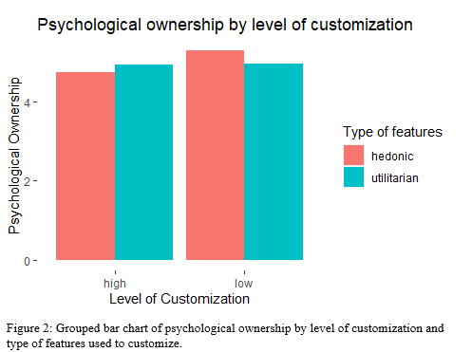For psychological ownership, one two-way ANOVA test was run to see if this variable is influenced by the interaction between the independent variable and the moderator without the effect of the covariates. When the ANOVA was performed, there are no significant results regarding the third hypothesis (F(1,256) =2.13, p = .15). Hence the H3 cannot be accepted. If we take a deeper glance at the collected data regarding the mediator and each of the four experimental conditions, is possible to see a high degree of dispersion (low R squared), making it difficult to identify a pattern between the four groups and the mediator variable (M Hedonic-High = 4.74, SD = 1.61; M Hedonic-Low = 5.29, SD = 0.998; M Utilitarian-High = 4.93, SD = 1.49; M Utilitarian-Low = 4.95, SD = 1.61).

|  |  |  |  |
| --- | --- | --- | --- |
| Psychological Ownership | | | |
| Level of customization | Hedonic | Utilitarian | Mean |
| High-level | 4.74 (σ = 1.61) | 4.93 (σ = 1.49) | 4.83 (σ = 1.55) |
| Low-level | 5.29 (σ = 0.99) | 4.95 (σ = 1.61) | 5.12 (σ = 1.34) |

Table 3: Mean and standard deviation of psychological ownership by the level of customization and type of features used to customize.

### *4.5.2 Willingness to pay – Dependent variable*

For the dependent variable, two ANOVA tests were run to see if this variable is influenced by the level of customization and its interaction with the moderator without the effect of the covariates. When the first one-tail ANOVA was run, was possible to see that the effect of the independent variable, on willingness to pay, is not significant (F(1,258) = .624, p = .43) although the mean for 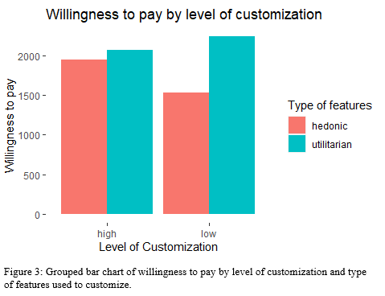the high-level condition is higher than the low condition (M High = 2006, SD = 1254) (M Low =1881, SD = 1295); therefore, H1 has to be rejected. The effect of the interaction (IV*MOD) is (F(1,256)= 3.56, p = .06). Although it was so close to being significant, based on the confidence interval stated for this research, we have to reject H2. If we analyze the result by the means of each group, it is possible to see how, in general, the average willingness to pay is higher for the two groups with the utilitarian condition assigned (M Utilitarian-High = 2067, SD = 1324; M Utilitarian-Low = 2242, SD = 1361; M Hedonic-High = 1944, SD = 1188; M Hedonic-Low = 1531; SD = 1132). Table 4 summarizes all the findings regarding the dependent variable.

|  |  |  |  |
| --- | --- | --- | --- |
| Willingness to Pay | | | |
| Level of customization | Hedonic | Utilitarian | Mean |
| High-level | 1944 (σ = 1188) | 2067 (σ = 1324) | 2006 (σ = 1254) |
| Low-level | 1531 (σ = 1132) | 2242 (σ = 1361) | 1881 (σ = 1295) |

Table 4: Mean and standard deviation of willingness to pay by the level of customization and type of features used to customize.

Although, when the ANOVA tests were performed, the results were not the expected ones, it is possible to highlight that there is a significant difference when the one-tail ANOVA is run with the type of features as a unique treatment variable and willingness to pay as the outcome variable. Table 5 contains a summary of the results of the one-way ANOVA tests, but in this case, the moderator was measured individually rather than in its interaction with the independent variable.

|  |  |  |
| --- | --- | --- |
| Summary one-way ANOVA | | |
| Variables | Level of customization | Type of features |
| Psychological ownership | F (1,258) = 2.55; p = .11 | F (1,258) = .19; p = .66 |
| Willingness to pay | F (1,258) = .62; p = 0.43 | F (1,258) = 7.16; p = .01 |

Table 5: F-values and p-values of one-tail ANOVA for each relationship between the two treatment variables and both, the mediator and the dependent variable. The results of the moderator are not based on its interaction with the IV, rather is just its direct effect on each of the outcome variables.

### *4.5.3 Hayes Bootstrapping mediation analysis model 8*

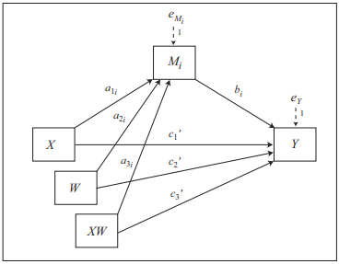To determine the possible mediation-moderation effect in our model, model 8 in the PROCESS macro developed by Hayes was executed. Figure 3 depicts the statistical diagram with all the relevant paths for the model.

Figure 4: statistical diagram model 8 Hayes.

First, the model was run without any covariate, the detailed results could be found in appendix 3.7. In this initial assessment, it is possible to highlight how the interaction of the independent variable with the moderator affected both outcome variables, psychological ownership and willingness to pay (a3 = -.523, p = .145; c3 = 716.77, p = .018).

Table 6 and Table 7 contain the summarized information of the bootstrapping analysis with, psychological ownership and willingness to pay as outcome variables respectively. It is also important to mention that in both models, all the covariates determined for the study were included. For the first model, which was performed with psychological ownership as the outcome variable (Table 6), it is important to highlight how this analysis confirms what was determined previously about the interaction between the treatment variables and its influence on PO (p = 0.128), although is not possible to say that is significant, it was close to being. Regarding the covariates the one with the highest degree of significance was knowledge got by respondents about cars (p = 0.014).

About table 7, it is possible to highlight several things. First is that in this model (model 2 with WTP as the outcome variable) the interaction between the treatment variables and the outcome variable, for this case willingness to pay, is significant (p = 0.039). This is an important output because gives us relevant insights into the moderating role and its influence on the relationship between the level of customization and willingness to pay. Second is the influence of the mediator on the dependent variable (p < 0.001). This result is in concordance with the individual correlation assessment made between both variables (t(258) = 4.280, p < 0.001). Although the correlation coefficient is relatively low due to the scattering in the dataset, there is a significant influence of psychological ownership on willingness to pay. Third, regarding the covariates, again the unique one with a significant effect on the outcome variable was the knowledge got by respondents about cars (p = 0.035).

Despite the significant influence of the knowledge about cars covariate, on almost all other variables of the model (see appendix 3.5 for correlations and p-values), when the ANOVA tests reported above, were run again with this covariate, the results did not change significantly. For instance the effect of the interaction of IV and moderator, on willingness to pay barely changed (F(1,255) = 3.503, p = .062), while for psychological ownership the change was quite low as well (F(1,255) = 2.33, p = .13). If a deeper glance is taken on the direct effect of the level of customization on willingness to pay (F(1,257) = 1.197, p = .275), is possible to conclude that although the p-value decreased, it is still not significant. All the detailed results of these tests could be found in appendix 3.6.

|  |  |  |  |  |
| --- | --- | --- | --- | --- |
| Model 1 Bootstrapping for Psychological Ownership | | | | |
| Variable | Path | Coeff | SE | P-value | |
| Level of customization (IV) | a1 | .507 | .249 | .046 | |
| Type of features (MOD) | a2 | .329 | .286 | .202 | |
| IV*MOD | a3 | -.545 | .371 | .128 | |
| Gender (COV) |  | -.291 | .210 | .154 | |
| Car knowledge (COV) |  | .108 | .044 | .014 | |
| Favorite means of transportation (COV) |  | -.129 | .762 | .511 | |
| Age (COV) |  | .327 | .590 | .603 | |
| Model summary |  |  |  |  | |
| Total $R^{2}$ | .098 |  |  |  | |
| p | .039 |  |  |  | |
| F | 1.771 |  |  |  | |

Table 6: Result of the bootstrapping analysis with psychological ownership as the outcome variable.

Notes: The p-values are two-sided. This means that low p-values show a significant difference between the groups but these probably are not the best to test the previously stated hypotheses. For this model, the base conditions are High-level for the IV and Hedonic for the MOD.

|  |  |  |  |  |
| --- | --- | --- | --- | --- |
| Model 2 Bootstrapping for Willingness to Pay | | | | |
| Variable | Path | Coeff | SE | P-value | |
| Psychological ownership (MED) | b1 | 221. | 54. | .001 | |
| Level of customization (IV) | c1 | -581. | 214. | .001 | |
| Type of features (MOD) | c2 | 142. | 217. | .513 | |
| IV*MOD | c3 | 627. | 302. | .039 | |
| Gender (COV) |  | -8. | 172. | .963 | |
| Car knowledge (COV) |  | 79. | 37. | .035 | |
| Favorite means of transportation (COV) |  | 500. | 643. | .414 | |
| Age (COV) |  | 531. | 496. | .417 | |
| Model summary |  |  |  |  | |
| Total $R^{2}$ | .176 |  |  |  | |
| p | .000 |  |  |  | |
| F | 3.233 |  |  |  | |

Table 7: Result of the bootstrapping analysis with psychological ownership as the outcome variable.

Notes: The p-values are two-sided. This means that low p-values show a significant difference between the groups, but these probably are not the best to test the previously stated hypotheses. For this model, the base conditions are High-level for the IV and Hedonic for the MOD.

Other relevant and interesting insights could be interpreted through the coefficients. For instance, the coefficient produced in model 1 regarding the independent variable is positive, but in model 2 is negative, this means that, on average, the respondents on the high condition were willing to pay more for the product than those in the low condition; but, at the same time they showed lower psychological ownership compared with the opposite condition related to the independent variable.

When the overall outputs were analyzed to determine if there is moderated mediation effect in the model, the approach, given by Hayes (2022) was followed. According to it, to make inferences regarding the moderated mediation effect involves determining whether an interval estimate, for the direct and indirect paths, includes zero. For the case of this study, the bootstrap interval includes zero (LLCI = -296; ULCI = 44); therefore, there is not enough evidence to support a significant moderated mediation effect in this model. It is not possible to be certain that the indirect effect was caused by the moderator if the confidence interval encompassed zero (Hayes, 2022). Based on the previous statements, the null hypotheses for H4 and H5 cannot be rejected.

### *4.5.4 Main analysis summary*

### Table 8 contains a summary of all of the hypotheses and their conclusions.

|  |  |  |
| --- | --- | --- |
| H | Hypothesis | Conclusion |
| H1 | Products with a high level of customization (10 customized features) will produce a higher willingness to pay than products with a low level of customization (5 customized features) | Rejected: according to the one-way ANOVA, the direct effect between the level of customization and willingness to pay is not significant (p = 0.43) |
| H2 | Products with a high level of customization (10 customized features) will produce a higher willingness to pay than products with a low level of customization (5 customized features) and this relationship will be stronger for products customized through hedonic features than products customized through utilitarian ones. | Rejected: although the interaction between IV and MOD is significant according to the bootstrapping test and quite close to being significant based on one-way ANOVA, utilitarian features showed a higher WTP than hedonic ones. |
| H3 | Products with a high level of customization (10 customized features) will develop stronger psychological ownership, in customers, than products with a low level of customization (5 customized features) and this relationship will be stronger for products customized through hedonic features than products customized through utilitarian ones. | Rejected: both, the bootstrapping test and the one-way ANOVA showed a small p-value but not enough to consider a significant difference in the groups. |
| H4 | Products with a high level of customization (10 customized features) will produce a higher willingness to pay than products with a low level of customization (5 customized features) and the relationship will be mediated by psychological ownership. | Rejected: According to the bootstrapping analysis run with all, none and just with one covariate, the bootstrap intervals contain cero; therefore, it is not possible to talk about an actual mediation effect on this study. |
| H5 | Products customized through hedonic features will produce a higher willingness to pay than products customized through utilitarian features and the relationship will be mediated by psychological ownership. |

Table 8: summary of the main analysis with all the hypotheses and their conclusions.

# Chapter 5 - Discussion, conclusions and recommendations

## *5.1 Conclusions and discussion*

The two main objectives of this study were, first to determine if the tendency of consumers to pay premium prices for customized products was explained by psychological ownership and second to see to what extent the type of features used to customize products could affect the relationship between the level of customization of a product and both, psychological ownership and willingness to pay.

To handle these targets some hypotheses were stated. The first was focused on understanding how willingness to pay was affected by the level of customization on a product. Although the mean of willingness to pay was higher for the expected conditions, the results were not significant according to, the one-way ANOVA. This lack of significant difference could have been produced, following Dellaert & Stremersch (2005) contribution, perhaps because the number of modules to customize a product, probably, is not the most relevant parameter, at least for the good used in the experiment, at the time of setting a customization configuration, for this reason, there is a lack of significative difference in the willingness to pay between the high and low level conditions.

The second and third hypotheses were aimed to identify a possible moderation effect of the type of features used to customize products on the relationship between the level of customization on a product and both, psychological ownership and willingness to pay. For both cases, the interactions, carried out using two-way ANOVA, were close to being significant but in the bootstrapping analysis, the interaction between the moderator and the independent variable, and their influence on willingness to pay was in fact significant.

Although the p-value obtained in the measurement of the interaction and its effect on the dependent variable could be considered positive; again, the direction of the effect was not the expected one. Of the 4 experimental groups, the two related to the utilitarian condition showed a higher WTP than those linked with the hedonic one. These results go against some theories, previously exposed in chapter 2, like those proposed by, Dhar & Wertenbroch (2000) or Shu & Peck (2011) which say that hedonic items tend to produce more positive effects, on respondents, than utilitarian ones. This contradiction could be produced and explained by the selected product which was customized by respondents. First, although the respondents were able to identify correctly the utilitarian and hedonic components of the car, through the pre-test, the product as a whole could be perceived more as utilitarian given that it fulfills a specific goal, for that reason, participants probably valued higher utilitarian attributes than hedonic ones. Second, the model of the car, Ford Fiesta 2022, also could be seen as a regular car that is not very linked with customization purposes, if the shown car had been a more extravagant or fancy model (e.g., a Lamborghini Gallardo, Porsche 911) the interpretation of the respondents probably would have been different and the result would have leaned more towards the hedonic condition than to the utilitarian one.

The last hypotheses were about the possible mediating role of psychological ownership on the relationship between both, level of customization and type of features used to customize, and willingness to pay. This procedure was crucial in determining whether these variables were the cause of why customers pay more for customized goods. Although a significant correlation was found between WTP and the mediator, the final results, supported by Hayes’s (2022) conditional analysis and bootstrapping technique, do not allow us to say that psychological ownership mediates the relationships initially mentioned.

Initially, the findings of this study are aligned with the theory previously discussed in chapter two regarding psychological ownership. As was said by Morewedge et al (2021) psychological ownership is positively related to WTP and this research confirms it. Nevertheless, these findings do not match other research contributions like the one made by Atasoy & Morewedge (2018) who proposed an approach where psychological ownership performs as a mediator between product format and willingness to pay. This could be explained because in the experiment carried out by Atasoy & Morewedge (2018) but also in the one made by Bonaventure & Chebat (2015), which also used PO as a mediator, both of them used physical interaction between the participant and the product as part of the manipulation strategy.

In summary, there were not enough significant results to affirm that there is a moderated mediation effect in this experiment; however, there are some interesting insights that are worth to be highlighted. The most interesting significant finding was the one related to the interaction between the level of customization the and type of features used to customize products and its influence on willingness to pay. From it, we learned that for this experiment, participants valued more utilitarian attributes than hedonic which is a statement that goes against some research papers related to customization and willingness to pay literature. Also, was interesting to see the level of significance in the relationship between psychological ownership and WTP. Finally, is worth reminding the influence of the knowledge about cars held by the respondents on the two previously mentioned variables.

## *5.2 Managerial implications.*

As explained previously, based on the literature research, customers are willing to pay premium prices for customized goods. With the development of new technologies and digital platforms, each time is easier for companies to offer customization products to their customers. The actual discussion, regarding customization, is about what kind of configurations should be offered to customers, based on several features related to the customization modules, and the product itself. This implication is completely aligned with the research written by Dellaert & Stremersch (2005), which aimed to explain why consumers prefer one mass customization configuration over another. Some results of this research don’t match with the ones provided by the research literature checked in chapter 2, probably due to the customized product and the way that it was modified.

Another interesting implication for companies is the fact that customers' prior knowledge of the product that needs to be customized, actually matters. Of all the covariates, this one was unique that actually had a positive significant influence on both, willingness to pay and psychological ownership. This implication again is aligned with the research made by Dellaert & Stremersch (2005), which states that expert customers are a potentially appealing target sector for mass customization.

## *5.3 Limitations and future research*

The present research has some limitations but also some recommendations and opportunities for future research.

Regarding the limitations, the biggest one is regarding the means used to carry out the experiment. Although the experiment should have been carried out through online means, because nowadays all customization applications are online, the main tool used which was Qualtrics is not the best one in order to simulate a mass customization application. This is important to consider given that, for the manipulation to be successful, it was important to simulate the most appealing and realistic customization environment to get the information required.

Another limitation is related to the kind of experiment used for this research. According to Reips (2000), online experiments have issues related to the extent to which they control the experimental situation; therefore, for future research, probably the best way to conduct it is through a kind of mixture between online and lab experiment sessions, where the participants could customize the product through online means but under a more controlled environment.

Hopefully, these recommendations will be borne in mind by future research to understand better the main issues related to customization and its relationships with psychological ownership and willingness to pay.

# *References*

Abraham, M., Archacki, R., Fanfarillo, S., & Esteve, J. (2019, June 04). *The Next Level of Personalization in Retail*. Retrieved from BCG: https://www.bcg.com/publications/2019/next-level-personalization-retail

Arısal, İ., & Cömert, Y. (2016). The effect of hedonic and utilitarian motives on customer behavior: A comparison study between Turkish and Spanish university students. *European Journal of Business and Social Sciences*, 99-112.

Arora, N., Ensslen, D., Lars, F., Liu, W., Robinson, K., Stein, E., & Schüler, G. (2021, November 12). *The value of getting personalization right—or wrong—is multiplying*. Retrieved from McKinsey & Company: https://www.mckinsey.com/capabilities/growth-marketing-and-sales/our-insights/the-value-of-getting-personalization-right-or-wrong-is-multiplying

Atasoy, O., & Morewedge, C. (2018). Digital Goods Are Valued Less Than Physical Goods. *Journal of Consumer Research*, 1343-1357.

Batra, R., & Ahtola, O. (1990). Measuring the Hedonic and Utilitarian Sources of Consumer Attitudes. *Marketing Letters*, 159-170.

Belk, R. (1998). Possessions and the Extended Self. *Journal of Consumer Research*, 139-168.

Bell, S. (2009). Experimental Design. In R. Kitchin, & N. Thrift, *International Encyclopedia of Human Geography* (pp. 672-675). Elsevier Science.

Birkett, S. (2021). *99 Interesting Car Buying Statistics & Trends*. Retrieved from FindTheBestCarPrice: https://www.findthebestcarprice.com/car-buying-statistics-trends/#Car_Buyer_Demographics_Preferences

Birnbaum, M. (2009). Designing online experiments. In A. Joinson, K. McKenna, T. Postmes, & U.-D. Reips, *Oxford Handbook of Internet Psychology* (pp. 389-402). Oxford Academic.

Blakely, S. (2022, August 21). *Product Features: 4 Types of Product Features*. Retrieved from MasterClass: https://www.masterclass.com/articles/product-features

Bonaventure, S., & Chebat, J. C. (2015). Psychological ownership, touch, and willingness to pay for an extended warranty. *Journal of Marketing Theory and Practice*, 224-234.

Botti, S., & Mcgill, A. (2011). The Locus of Choice: Personal Causality and Satisfaction with Hedonic and Utilitarian Decisions. *Journal of Consumer Research*, 1065-1078.

Boudet, J., Gregg, B., Rathje, K., Stein, E., & Vollhardt, K. (2019, June 18). *The future of personalization—and how to get ready for it*. Retrieved from McKinsey&Co: https://www.mckinsey.com/capabilities/growth-marketing-and-sales/our-insights/the-future-of-personalization-and-how-to-get-ready-for-it

Britt, P. (2019, September 13). *Why Personalization Efforts Fail*. Retrieved from cmswire: https://www.cmswire.com/digital-experience/why-personalization-efforts-fail/

Budiu , R. (2018, May 13). *Between-Subjects vs. Within-Subjects Study Design*. Retrieved from NN Group: https://www.nngroup.com/articles/between-within-subjects/

Cardello, J., & Nielsen, J. (n.d.). *Customization Features Done Correctly for the Right Reasons.* Fremont: Nielsen Norman Group.

Chaudhury, B., Faure, A., Heuss, R., & Schleyer, T. (2021). *Calculating complexity: Maximizing the value of customization.* McKinsey & Company. Retrieved from Mc.

Chernev, A. (2004). Goal-Attribute Compatibility in Consumer Choice. *Journal of Consumer Psychology*, 141-150.

Clark, B. (2021, August 26). *Personalize vs Customize: How are they Different?* Retrieved from Acquire: https://acquire.io/blog/personalization-vs-customization/

Crowley, A., Spangenberg, E., & Hughes, K. (1992). Measuring the Hedonic and Utilitarian Dimensions of Attitudes Toward Product Categories . *Marketing Letters*, 239-249.

Cohen, J. (1992). A Power Primer. *Psychological Bulletin*, 155-159.

Cronbach, L. J. (1951). Coefficient Alpha and the Internal Structure of Tests. *Psychometrika*, 297-334.

Dellaert, B., & Stremersch, S. (2005). Marketing Mass-Customized Products: Striking a Balance Between Utility and Complexity. *Journal of Marketing Research*, 219-227.

Dhar, R., & Wertenbroch, K. (2000). Consumer Choice Between Hedonic and Utilitarian Goods. *Journal of Marketing Research*, 60-71.

Du, R., Hu, Y., & Damangir, S. (2015). Leveraging Trends in Online Searches for Product Features in Market Response Modeling. *Journal of Marketing*, 29-43.

Franke, N., Keinz, P., & Steger, C. (2009). Testing the Value of Customization: When Do Customers Really Prefer Products Tailored to Their Preferences? *Journal of Marketing*, 103-121.

Global Electronic Services. (2022, September 30). *Pros & Cons of Mass Customization*. Retrieved from Global Electronic Services: https://gesrepair.com/pros-cons-of-mass-customization/

Hair, J., Black, W., Babin, B., & Anderson, R. (2014). *Multivariate Data Analysis (7th Edition).* Harlow: Pearson Education.

Hall, E. (1966). *The Hidden Dimension.* Garden City: Doubleday.

Hayes, A. (2022). *Introduction to mediation, moderation, and conditional process analysis : a regression-based approach.* New York: The Guilford Press.

Hildebrand, C., Haubl, G., & Herrmann, A. (2014). Product Customization via Starting Solutions. *Journal of Marketing Research*, 707-725.

Huffman, C., & Kahn, B. (1998). Variety for Sale: Mass Customization or Mass Confusion. *Journal of Retailing*, 491-513.

Howell, B. (2022, November 1). *Online psychology experiments: everything you need to know*. Retrieved from Psychstudio: https://www.psychstudio.com/articles/online-experiments/

Irmak, C., & Goodman, J. (2013). Having Versus Consuming: Failure to Estimate Usage Frequency Makes Consumers Prefer Multifeature Products. *Journal of Marketing Research*, 44-54.

Jami, A., Kouchaki, M., & Gino, F. (2021). I Own, So I Help Out: How Psychological Ownership Increases Prosocial Behavior. *Journal of Consumer Research*, 698-715.

Jia, M., Wan, E., & Zheng, W. (2022). Stars versus Bars: How the Aesthetics of Product Ratings “Shape” Product Preference. *Journal of Consumer Research*, 1-25.

Lancaster, K. (1966). A New Approach to Consumer Theory. *Journal of Political Economy*, 132-157.

Lee, Y., & Kim, H. (2020). The Effect of Online Customization on Consumers’ Happiness and Purchase Intention and the Mediating Roles of Autonomy, Competence, and Pride of Authorship. *International Journal of Human–Computer Interaction*, 403-413.

Leung, E., Cito, M., Paolacci, G., & Puntoni, S. (2021). Preference for Material Products in Identity-Based Consumption. *Journal of Consumer Psychology*, 672–679.

Li, D., & Atkinson, L. (2020). The role of psychological ownership in consumer happiness. *Journal of Consumer Marketing*.

Makkonen, M., Halttunen, V., & Frank, L. (2011). The Effects of Gender, Age, and Income on the Willingness to Pay for Music Downloads. *BLED*, 102-113.

Morales, A., Amir, O., & Lee, L. (2017). Keeping It Real in Experimental Research—Understanding When, Where, and How to Enhance Realism and Measure Consumer Behavior. *Journal of Consumer Research*, 465-476.

Morewedge, C. (2021). Psychological ownership: implicit and explicit. *Current Opinion in Psychology* , 125–132.

Morewedge, C., Monga, A., Palmatier, R., Shu, S., & Small, D. (2021). Evolution of Consumption: A Psychological Ownership Framework. *Journal of Marketing*, 196-218.

Netzer, O., & Bellezza, S. (2021). *How to Recruit Respondents Cheaply and Quickly.* Retrieved from Columbia University: http://www.columbia.edu/~sb3761/HowtoRecruitRespondents.pdf

Nielsen, J. (2009, August 16). *Customization of UIs and Products*. Retrieved from Nielsen Norman Group: https://www.nngroup.com/articles/customization-of-uis-and-products/

Norton, M., Mochon, D., & Ariely, D. (2012). The IKEA effect: When labor leads to love. *Journal of Consumer Psychology*, 453-460.

Nowak, K. (2022, November 22). *History of the Ford Fiesta – top-selling vehicle in the UK - See more at: https://www.rivervaleleasing.co.uk/blog/posts/history-of-the-ford-fiesta-uk-best-selling-vehicle#sthash.R6q6CLLA.dpuf*. Retrieved from Rivervale Leasing: https://www.rivervaleleasing.co.uk/blog/posts/history-of-the-ford-fiesta-uk-best-selling-vehicle

Ortiz, P. (2022, October 07). *10 MOST POPULAR CAR BRANDS IN AMERICA (2022 UPDATE)*. Retrieved from House Grail: https://housegrail.com/most-popular-car-brands-in-america/

Pierce, J., & Van Dyne, L. (2004). Psychological Ownership and Feelings of Possession: Three Field Studies Predicting Employee Attitudes and Organizational Citizenship Behavior. *Journal of Organizational Behavior*, 439-459.

Pine, J., & Gilmore, J. (1997). The Four Faces of Mass Customization. *Harvard Business Review*.

Puligadda, S., Grewal, R., Rangaswamy, A., & Kardes, F. (2010). The role of idiosyncratic attribute evaluation in mass customization. *Journal of Consumer Psychology*, 369-380.

Reips, U.-D. (2000). The Web Experiment Method: Advantages, Disadvantages, and Solutions. *Psychology Experiments on the Internet*, 89-117.

Roy, R. (2021, April 16). *Top product customization challenges and ways to overcome them*. Retrieved from wtpbiz: https://www.wtpbiz.com/product-customization-challenges/

Sauter, M., Draschkow, D., & Mack, W. (2020). Building, Hosting and Recruiting: A Brief Introduction to Running Behavioral Experiments Online. *Brain Sciences*, 2-11.

Schreier, M. (2006). The value increment of mass-customized products: an empirical assessment. *Journal of Consumer Behaviour*, 317-327.

Shu, S., & Peck, J. (2011). Psychological ownership and affective reaction: Emotional attachment process variables and the endowment effect. *Journal of Consumer Psychology*, 439-452.

Simonson, I. (2005). Determinants of Customers’Responses to Customized Offers:Conceptual Framework andResearch Propositions. *Journal of Marketing*, 32-45.

Splashlight. (2017, August 10). *How Powerful is Visual Content for the E-Commerce Consumers*. Retrieved from Splashlight: https://splashlight.com/powerful-visual-content-e-commerce-consumer/

Smith, S., Roster , C., Golden , L., & Albaum , G. (2015). A multi-group analysis of online survey respondent data quality: Comparing a regular USA consumer panel to MTurk samples. *Journal of Business Research*, 3139-3148.

Statista. (2022). *Largest automobile markets worldwide in 2021, based on new car registrations*. Retrieved from Statista: https://www.statista.com/statistics/269872/largest-automobile-markets-worldwide-based-on-new-car-registrations/

Swait, J., & Adamowicz, W. (2001). The Influence of Task Complexity on Consumer Choice: A Latent Class Model of Decision Strategy Switching. *Journal of Consumer Research*, 135-148.

Teasdale, R. (2022, February 22nd). *11 Product Customization Statistics You Need to Know*. Retrieved from Kickflip: https://gokickflip.com/en/articles/product-customization-statistics/

Walcher, D., Leube, M., & Blazek, P. (2016). Gender Differences in Online Mass Customization: An Empirical Consumer Study Which Considers Gift-Giving. *International Journal of Industrial Engineering and Management*, 153-158.

Wiengarten, F., Singh, P., Fynes, B., & Nazarpour, A. (2017). Impact of mass customization on cost and flexiblity performances: the role of social capital. *Oper Manag Res 10*, 137-147.

Yale University. (2022, November 2). *Why randomize?* Retrieved from Yale University: https://isps.yale.edu/research/field-experiments-initiative/why-randomize

# *Appendices*

## *Appendix 1: Pre-test*

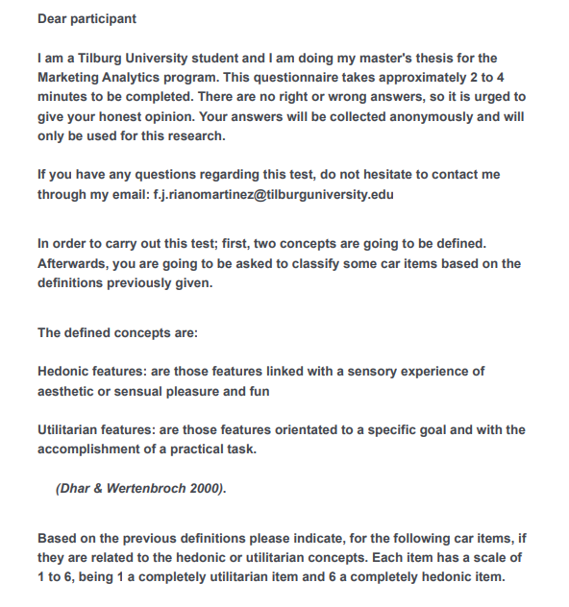

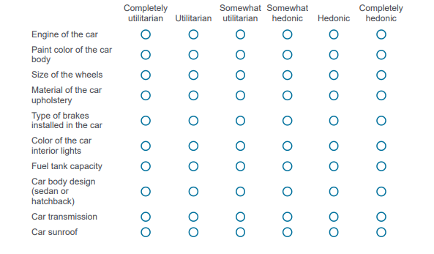

### *Appendix 1.1: Pre-test results*

|  |  |
| --- | --- |
| Participants | |
| Gender | Age |
| Male 12 | Min 25 |
| Female 10 | Max 45 |
| Total 22 | Mean 30 |

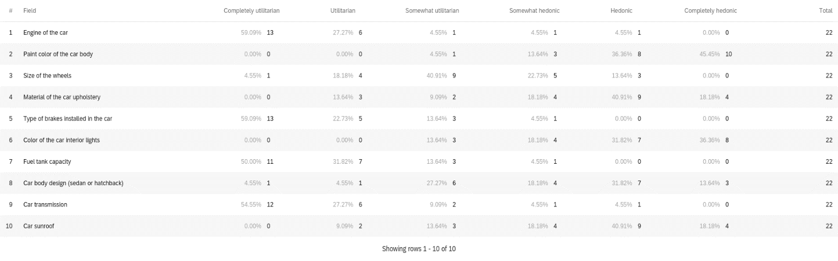

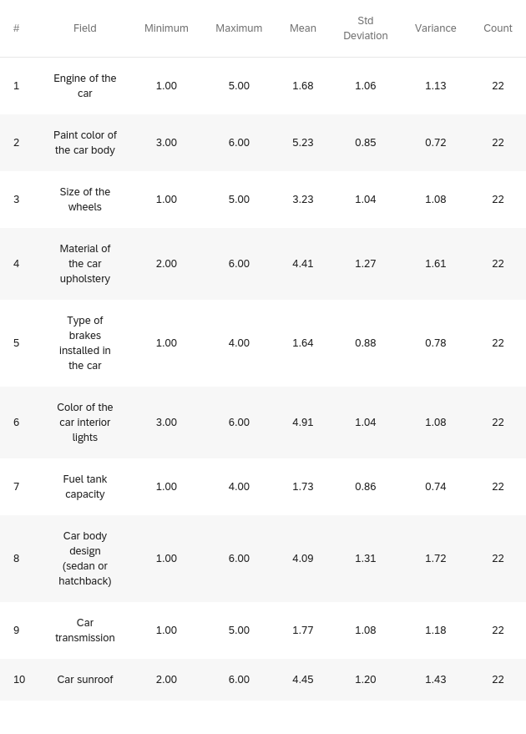

## *Appendix 2: Questionnaire*

### *Appendix 2.1 - Intro*

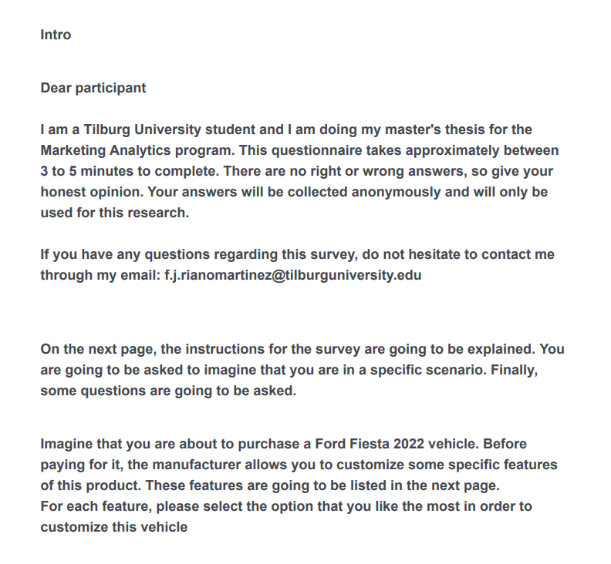

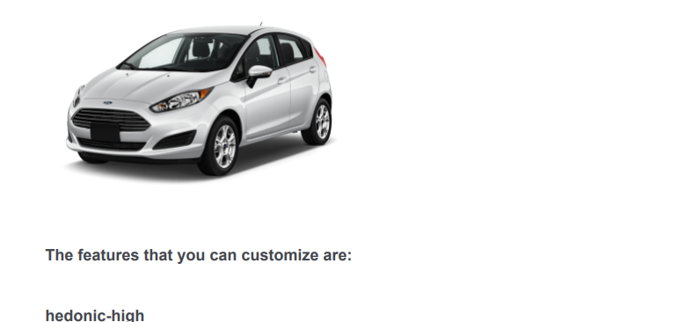

### *Appendix 2.2 - Hedonic & high condition*

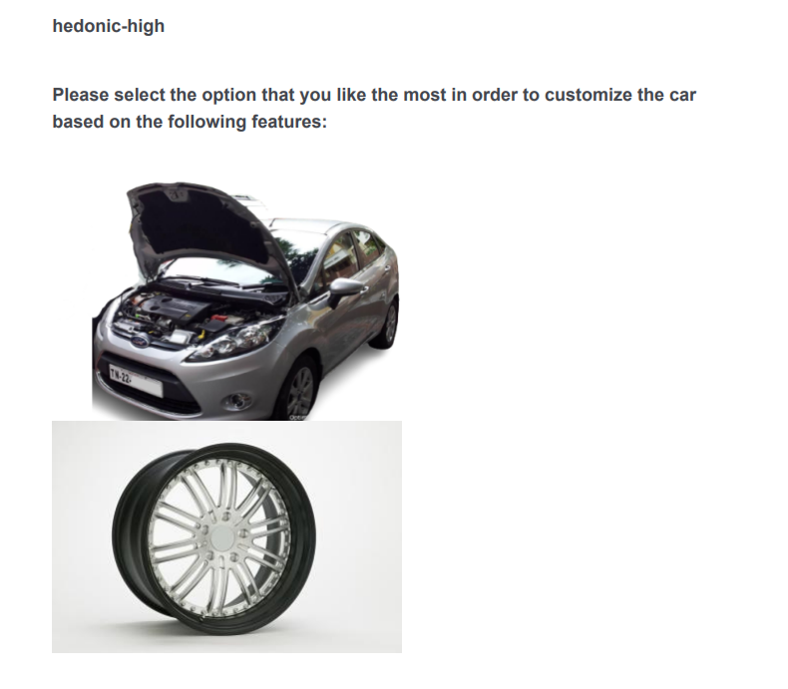

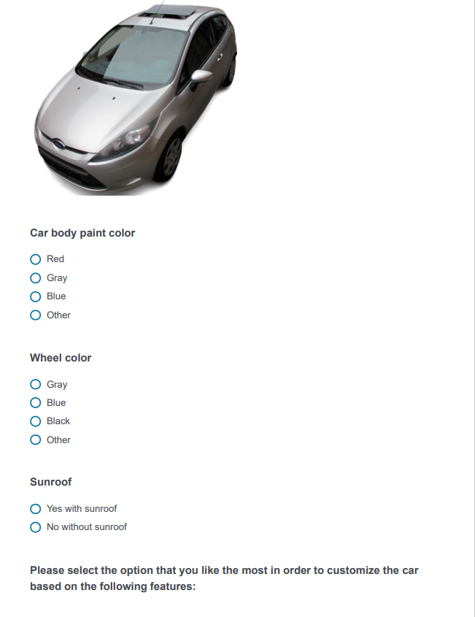

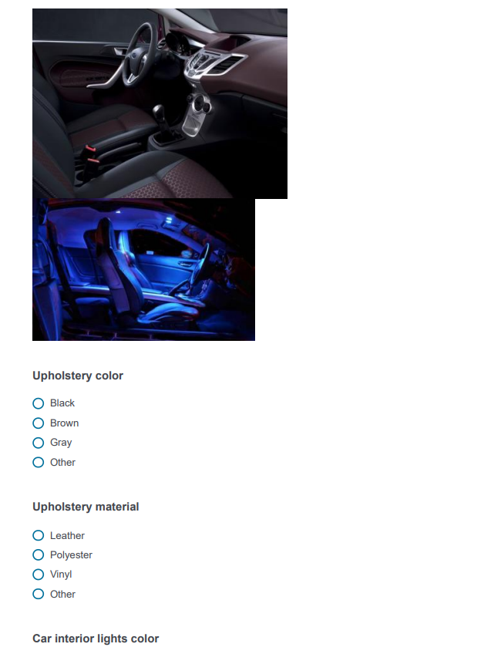

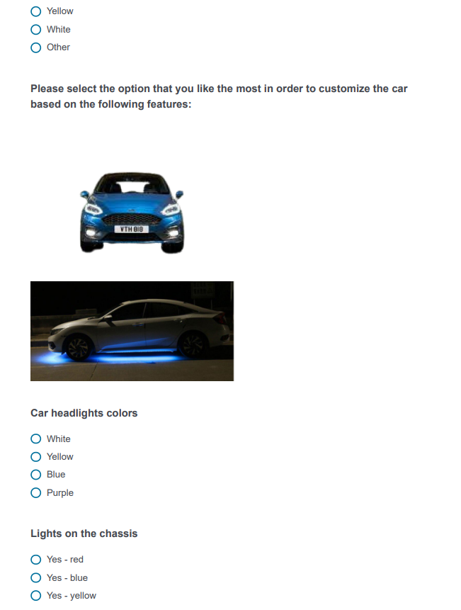

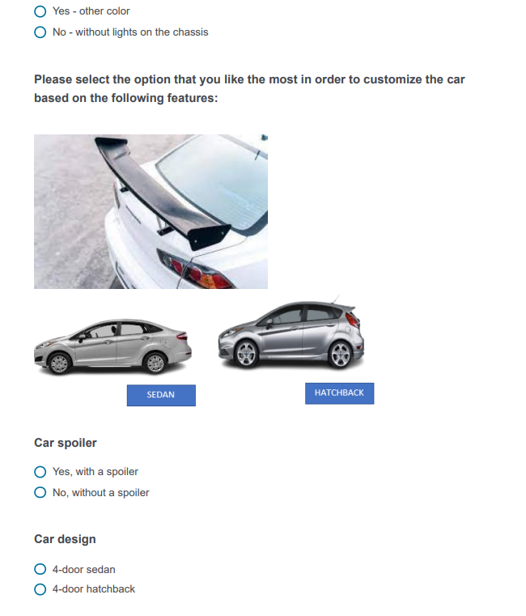

### *Appendix 2.3 - Hedonic & low condition*

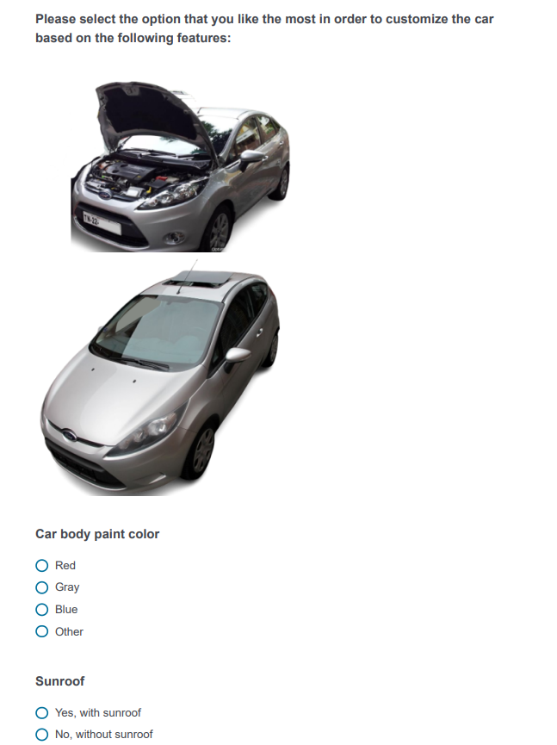

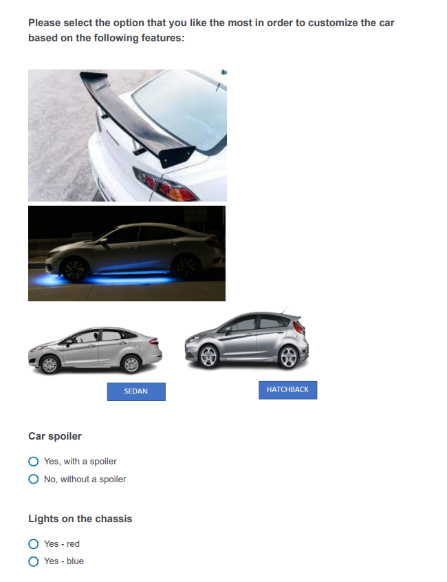

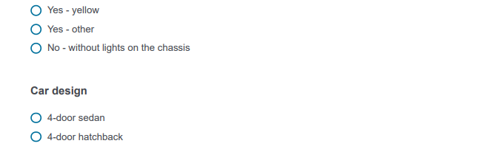

### *Appendix 2.4 - Utilitarian & high condition*

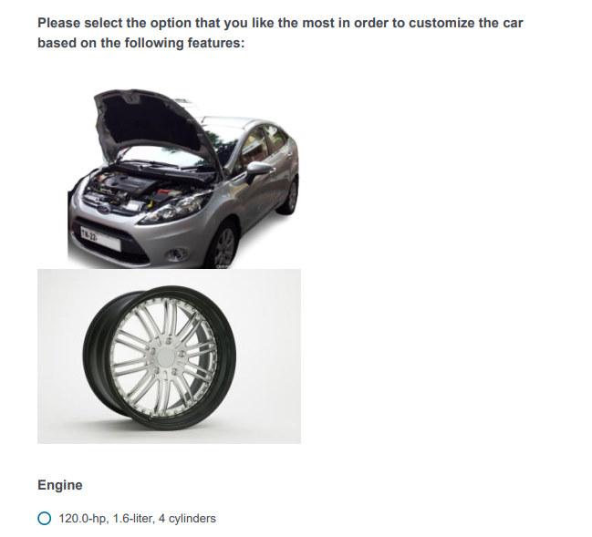

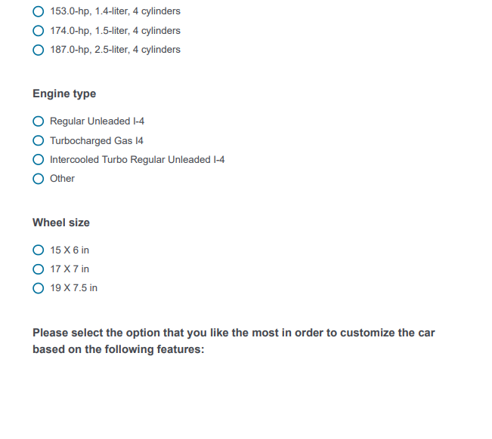

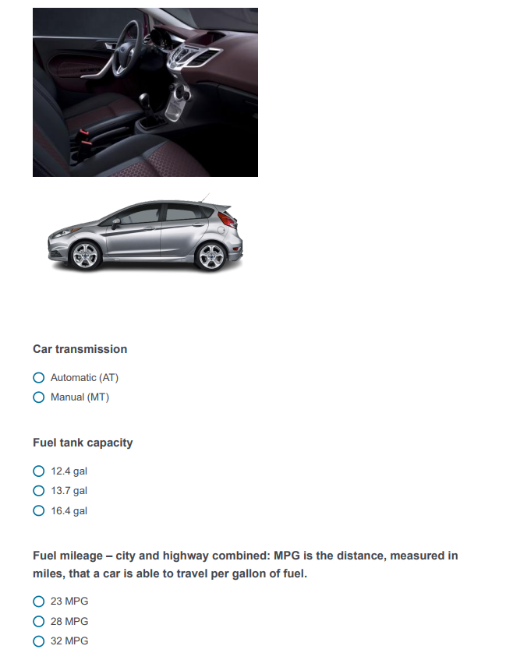

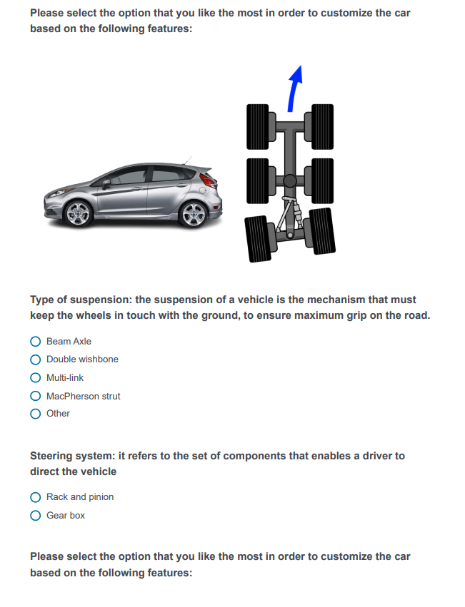

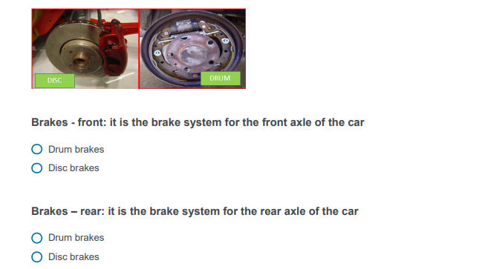

### *Appendix 2.5 - Utilitarian & low condition*

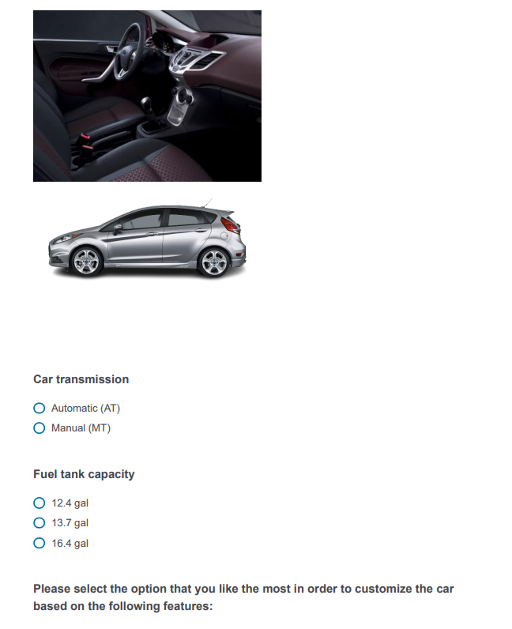

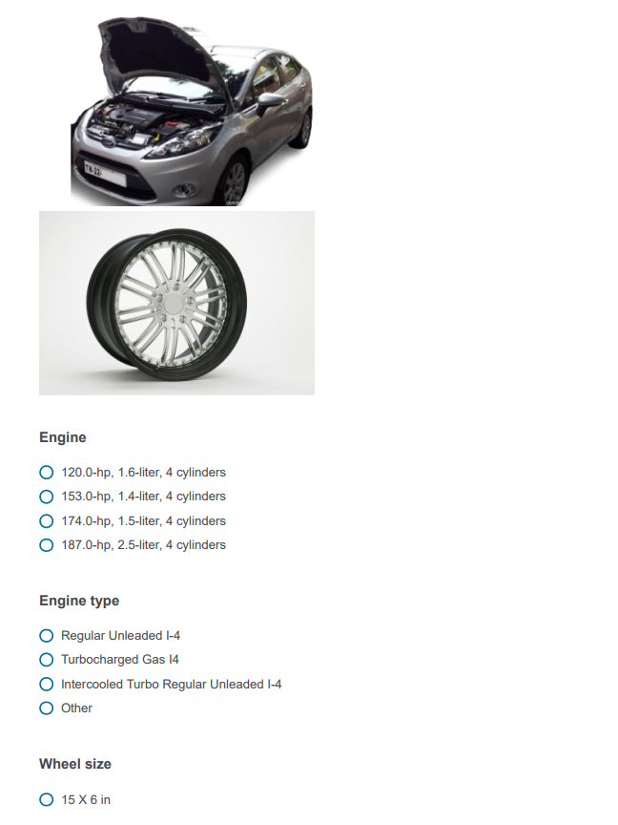

**

### *Appendix 2.6 Outcome variables measurement and covariates*

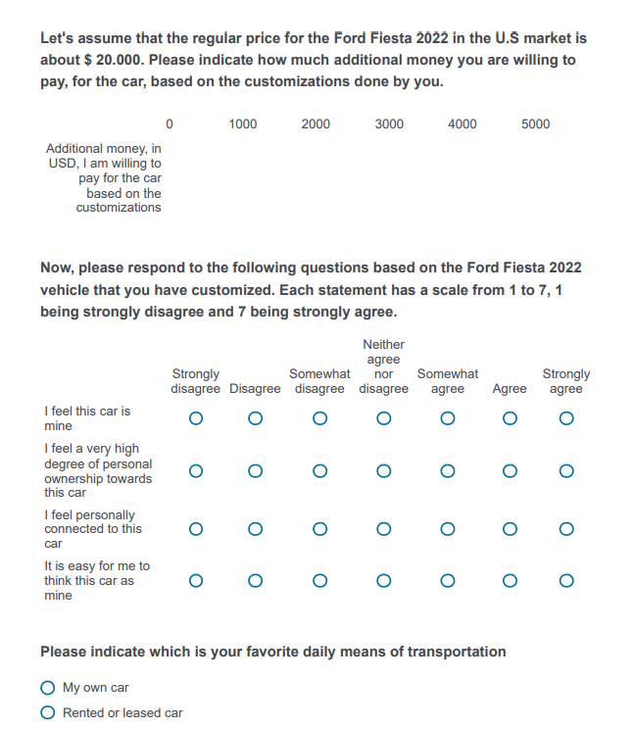

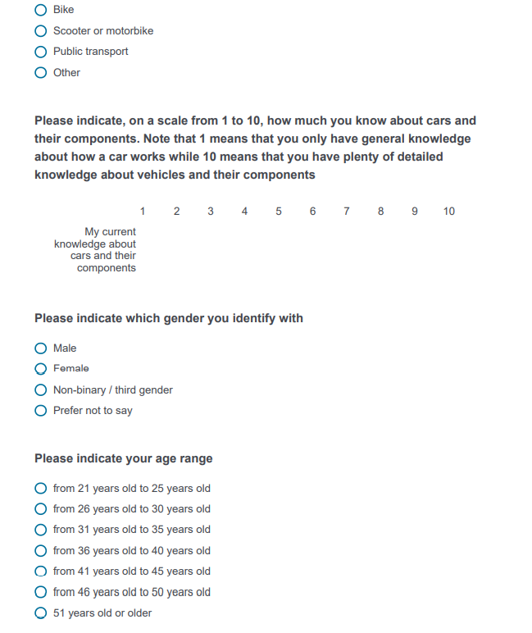

## *Appendix 3: Data analysis*

### *Appendix 3.1 Participants and demographics*

|  |  |
| --- | --- |
| Participants | |
| Gender | Age |
| Male 158 | Min 25 |
| Female 102 | Max 50 |
| Total 260 | Mean 36 |

### Appendix 3.2 Randomization

|  |  |  |  |  |
| --- | --- | --- | --- | --- |
| *Randomization using gender as the outcome variable* | | | | |
|  | *Sum of squares* | *Df* | *F-value* | *p-value* |
| *Intercept* | *20.800* | *1* | *87.6753* | *<2e-16* |
| *IV* | *0.096* | *1* | *0.4053* | *0.523* |
| *Residuals* | *61.208* | *258* |  |  |

### *Appendix 3.3 Cronbach’s Alpha – internal scale consistency*

|  |  |
| --- | --- |
| *Cronbach’s Alpha for psychological ownership scale* | |
| *Items* | *4* |
| *Sample units* | *260* |
| *Alpha* | *0.958* |

### *Appendix 3.4 Assumptions*

|  |  |  |  |  |
| --- | --- | --- | --- | --- |
| *Levene’s test* | | | | |
|  | *F-Value* | *Df1* | *Df2* | *Sig* |
| *Willingness to pay* | *.6752* | *1* | *258* | *.412* |
| *Psychological ownership* | *6.1742* | *1* | *258* | *.014* |

|  |  |  |  |
| --- | --- | --- | --- |
| *Test of normality: Shapiro – Wilk test* | | | |
|  | *W-statistic* | *Df* | *Sig* | |
| *Willingness to pay* | *.950* | *260* | *.000* | |
| *Psychological ownership* | *.918* | *260* | *.000* | |

### *Appendix 3.5 Correlations*

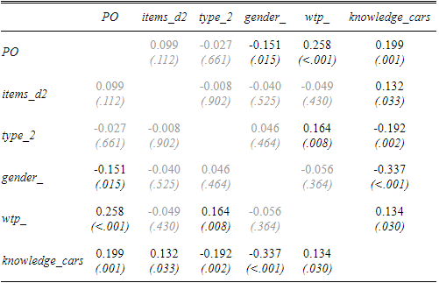

### *Appendix 3.6 ANOVAs results*

*ANOVA: Willingness to pay – Level of customization without covariates*

|  |  |  |  |  |
| --- | --- | --- | --- | --- |
|  | *Sum Sq* | *Df* | *F value* | *Pr(>F)* |
| *Between groups* | *1013501* | *1* | *0.6237* | *0.4304* |
| *Within groups* | *419263024* | *258* |  |  |

*ANOVA: Willingness to pay – Type of features without covariates*

|  |  |  |  |  |
| --- | --- | --- | --- | --- |
|  | *Sum Sq* | *Df* | *F value* | *Pr(>F)* |
| *Between groups* | *11342589* | *1* | *7.1561* | *0.007948* |
| *Within groups* | *408933937* | *258* |  |  |

*ANOVA: Willingness to pay – Level of customization*Type of features without covariates*

|  |  |  |  |  |
| --- | --- | --- | --- | --- |
|  | *Sum Sq* | *Df* | *F value* | *Pr(>F)* |
| *Between groups* | *5599411* | *1* | *3.5625* | *0.06023* |
| *Within groups* | *402372460* | *256* |  |  |

*ANOVA: Psychological ownership – Level of customization without covariates*

|  |  |  |  |  |
| --- | --- | --- | --- | --- |
|  | *Sum Sq* | *Df* | *F value* | *Pr(>F)* |
| *Between groups* | *5.34* | *1* | *2.5493* | *0.1116* |
| *Within groups* | *540.10* | *258* |  |  |

*ANOVA: Psychological ownership – Type of features without covariates*

|  |  |  |  |  |
| --- | --- | --- | --- | --- |
|  | *Sum Sq* | *Df* | *F value* | *Pr(>F)* |
| *Between groups* | *0.41* | *1* | *0.1929* | *0.6608* |
| *Within groups* | *545.03* | *258* |  |  |

*ANOVA: Psychological ownership – Level of customization*Type of features without covariates*

|  |  |  |  |  |
| --- | --- | --- | --- | --- |
|  | *Sum Sq* | *Df* | *F value* | *Pr(>F)* |
| *Between groups* | *4.45* | *1* | *2.1278* | *0.14587* |
| *Within groups* | *535.26* | *256* |  |  |

*ANOVA: Willingness to pay – Level of customization with knowledge about cars as a unique covariate*

|  |  |  |  |  |
| --- | --- | --- | --- | --- |
|  | *Sum Sq* | *Df* | *F value* | *Pr(>F)* |
| *Between groups* | *1913806* | *1* | *1.1974* | *0.2749* |
| *Within groups* | *410774798* | *257* |  |  |

*ANOVA: Willingness to pay – Type of features customization with knowledge about cars as a unique covariate*

|  |  |  |  |  |
| --- | --- | --- | --- | --- |
|  | *Sum Sq* | *Df* | *F value* | *Pr(>F)* |
| *Between groups* | *15759617* | *1* | *10.2039* | *0.00158* |
| *Within groups* | *396928988* | *257* |  |  |

*ANOVA: Willingness to pay – Level of customization*Type of features with knowledge about cars as a unique covariate*

|  |  |  |  |  |
| --- | --- | --- | --- | --- |
|  | *Sum Sq* | *Df* | *F value* | *Pr(>F)* |
| *Between groups* | *5350462* | *1* | *3.5032* | *0.06239* |
| *Within groups* | *389459133* | *255* |  |  |

*ANOVA: Psychological ownership – Level of customization with knowledge about cars as a unique covariate*

|  |  |  |  |  |
| --- | --- | --- | --- | --- |
|  | *Sum Sq* | *Df* | *F value* | *Pr(>F)* |
| *Between groups* | *2.93* | *1* | *1.445* | *0.2305* |
| *Within groups* | *520.99* | *257* |  |  |

*ANOVA: Psychological ownership – Type of features with knowledge about cars as a unique covariate*

|  |  |  |  |  |
| --- | --- | --- | --- | --- |
|  | *Sum Sq* | *Df* | *F value* | *Pr(>F)* |
| *Between groups* | *0.07* | *1* | *0.0321* | *0.8579* |
| *Within groups* | *523.85* | *257* |  |  |

*ANOVA: Psychological ownership – Level of customization*Type of features with knowledge about cars as a unique covariate*

|  |  |  |  |  |
| --- | --- | --- | --- | --- |
|  | *Sum Sq* | *Df* | *F value* | *Pr(>F)* |
| *Between groups* | *4.72* | *1* | *2.3333* | *0.1279* |
| *Within groups* | *516.21* | *255* |  |  |

### *Appendix 3.7 Hayes bootstrapping model 8 results*

*Hayes model 8 bootstrapping moderated mediation model*

*Y: wtp_ Willingness to pay*

*X: items_d2 Level of customization*

*M: PO Psychological ownership*

*W: type_2 Type of features used to customize*

*Covariates: Knowledge about cars, gender, age, favorite means of transportation*

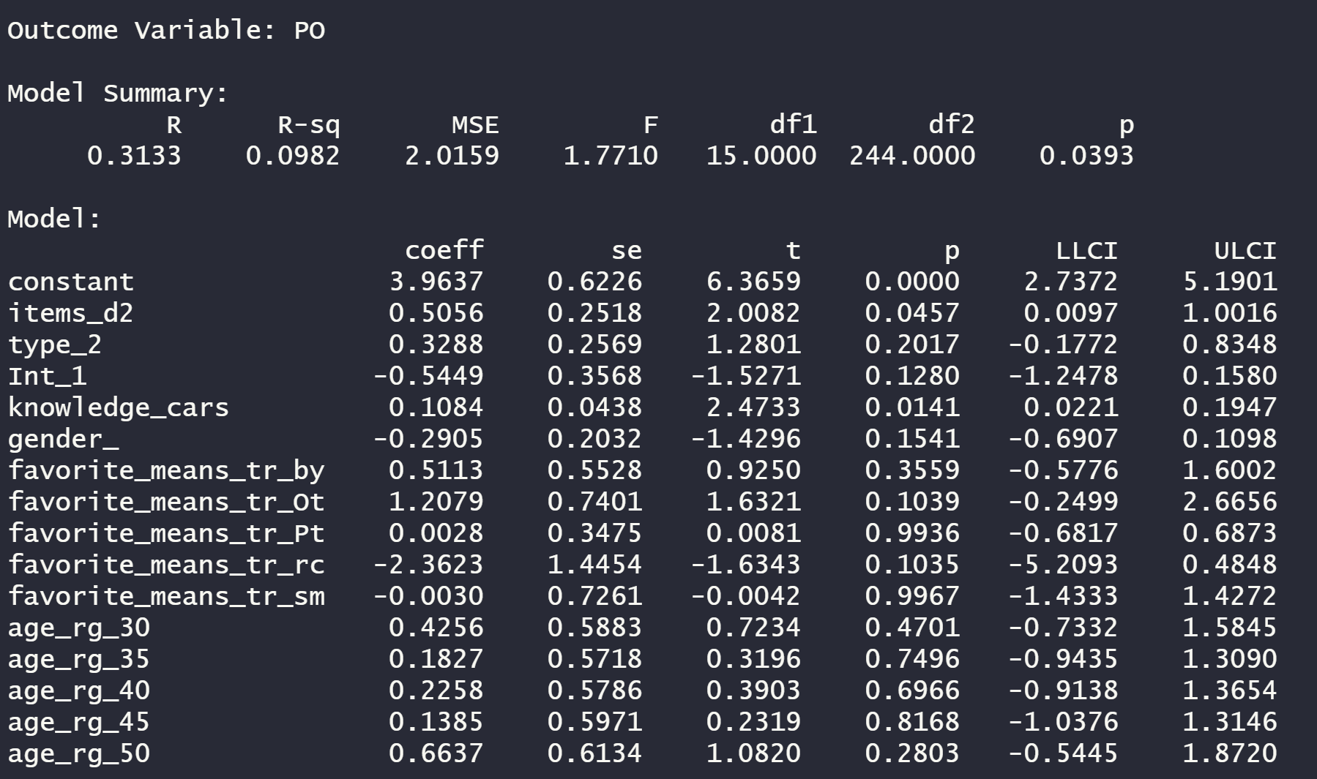

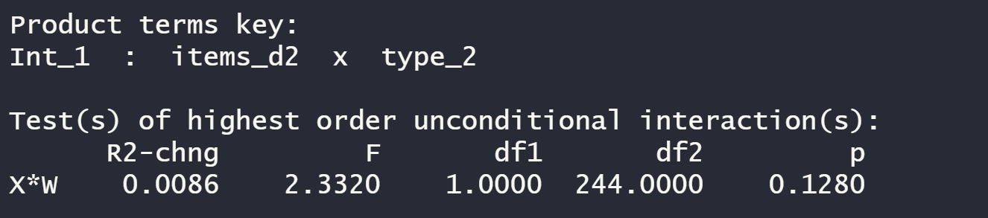

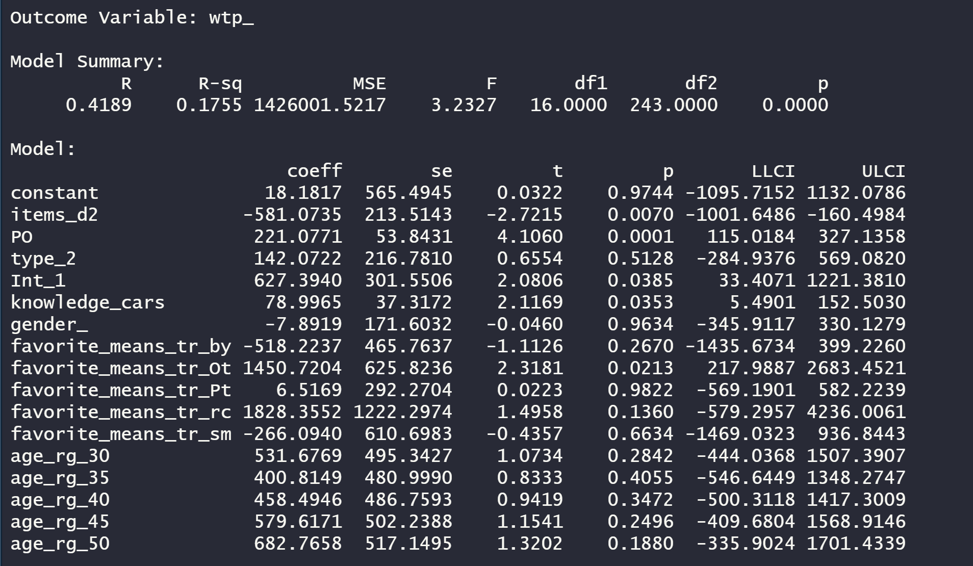

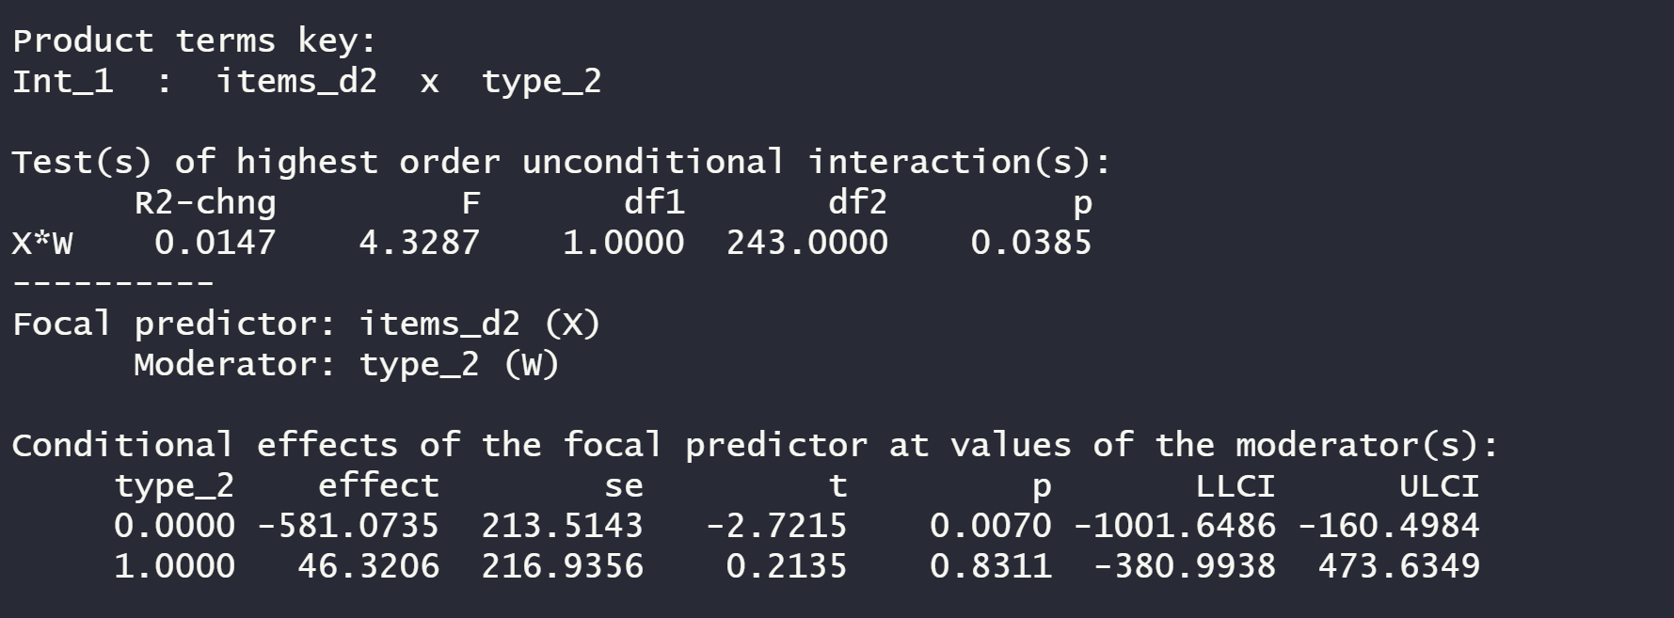

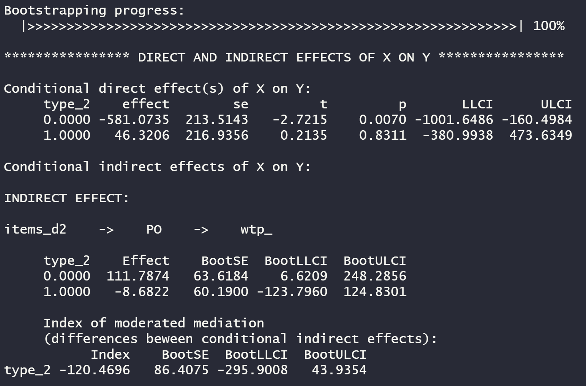

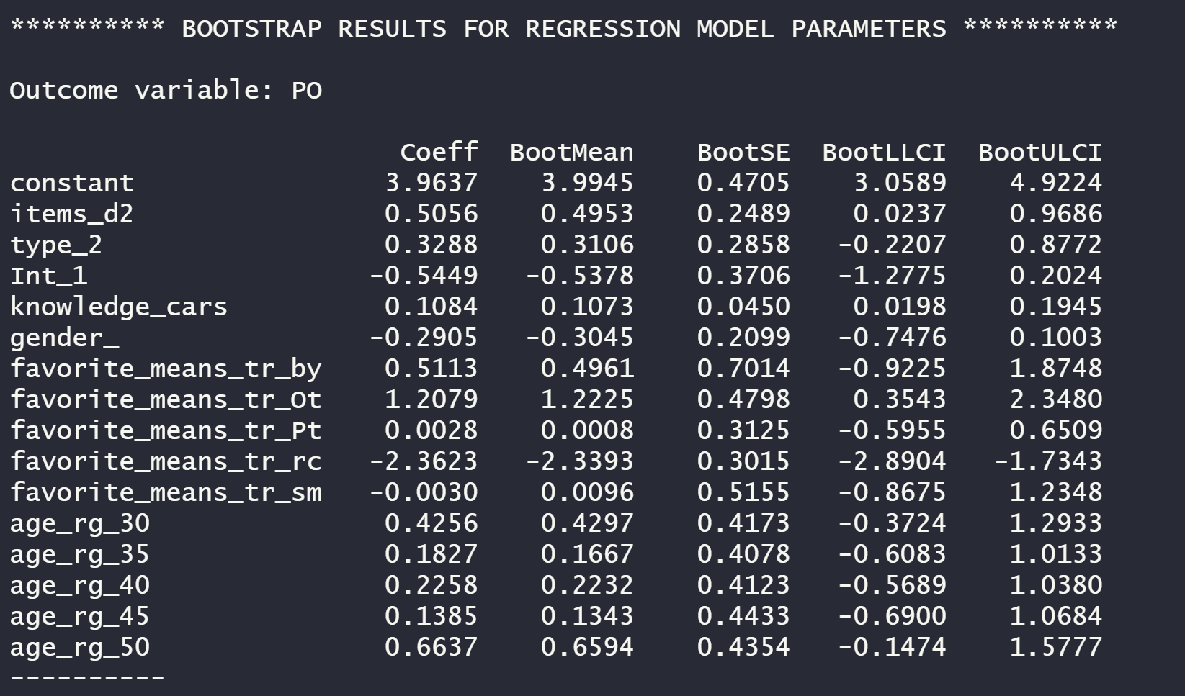

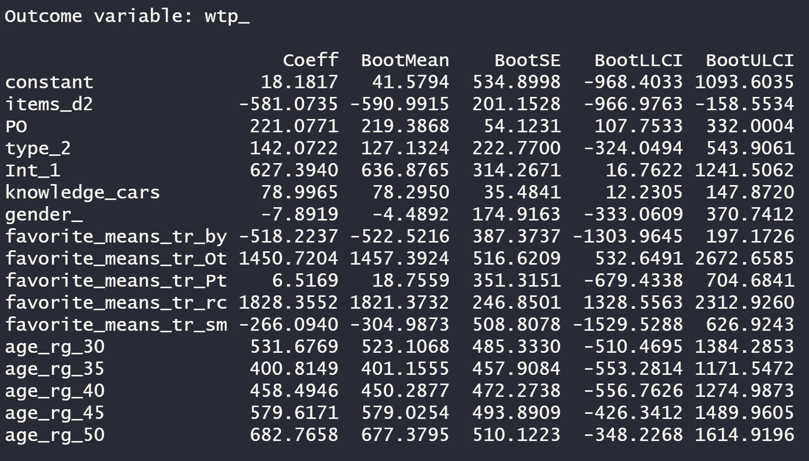

*Hayes model 8 bootstrapping moderated mediation model*

*Y: wtp_ Willingness to pay*

*X: items_d2 Level of customization*

*M: PO Psychological ownership*

*W: type_2 Type of features used to customize*

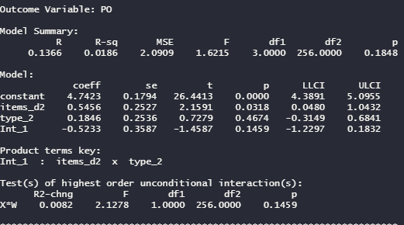

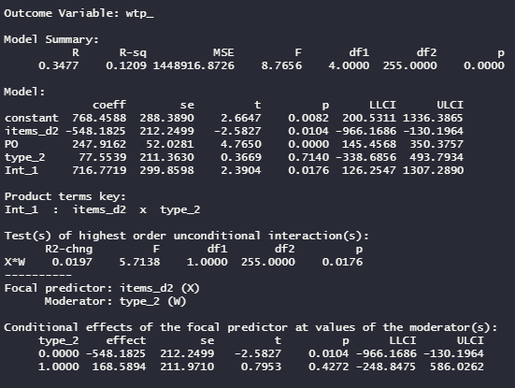

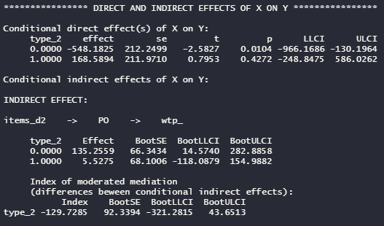

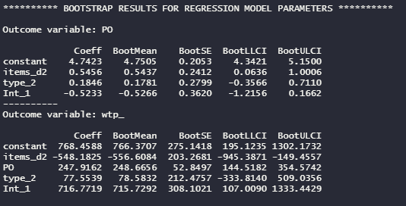

*Hayes model 8 bootstrapping moderated mediation model*

*Y: wtp_ Willingness to pay*

*X: items_d2 Level of customization*

*M: PO Psychological ownership*

*W: type_2 Type of features used to customize*

*Covariates: Knowledge about cars*

